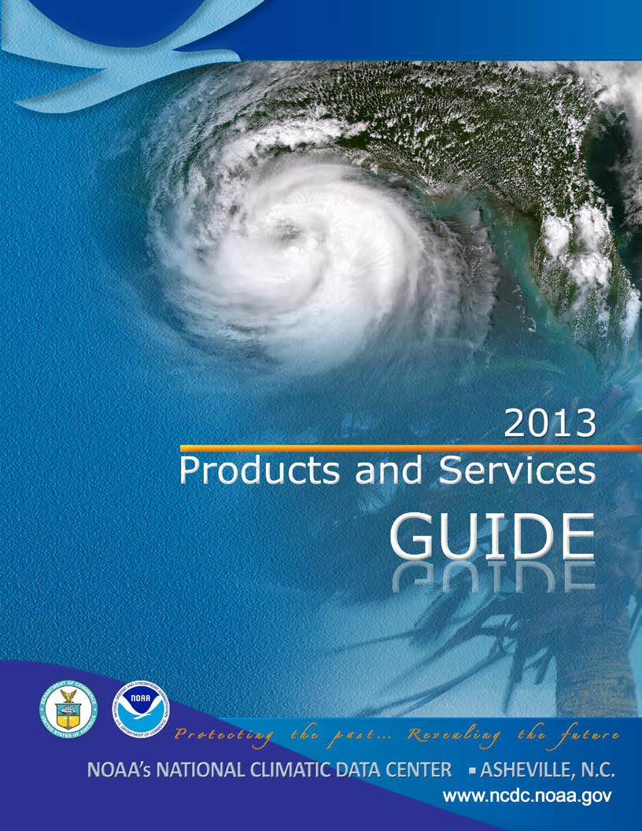

PRODUCTS AND SERVICES GUIDE

NOAA’s NATIONAL CLIMATIC DATA CENTER ASHEVILLE, NC



2013 Edition

Mark Lackey, Bryant Korzeniewski, Tamara Houston, Axel Graumann, John Kobar, Glenn Hyatt, Steve Ansari, Eric Wong, Bruce Bauer, Deb Franklin, Danny Brinegar, Katy Vincent, Sara Veasey, Regina Keller, DeWayne Cecil, Jeff Privette, Cheryl Preston

See http://www1.ncdc.noaa.gov/pub/data/inventories/2013psguide.pdf for a digital copy of this guide.

Table of Contents

Message from the Director ................................................................................................................. 4

NCDC 2012 Highlights.......................................................................................................................... 5

Online and Operational Services ....................................................................................................... 14
Web Navigation ........................................................................................................................... 15
In Situ Data .................................................................................................................................. 22
NEXRAD Products ........................................................................................................................ 40
Weather and Climate Toolkit....................................................................................................... 46
Satellite Data, Products and Services .......................................................................................... 50
Model Data, Products and Services ............................................................................................ 61
Paleoclimate Data ....................................................................................................................... 67
NOAA’s Regional Climate Centers ............................................................................................... 68

CD-ROM/DVD Products ..................................................................................................................... 70

Publications ....................................................................................................................................... 72

Climate Monitoring ........................................................................................................................... 73

NCDC Sectoral Engagement............................................................................................................... 79

NCDC Customer Service Contacts...................................................................................................... 80

A message from the Director, National Climatic Data Center

The National Climatic Data Center (NCDC) offers a wide range of products and services. Our users range from large engineering firms designing the latest in safe energy efficient structures, to the attorney documenting a weather event, to the individual planning for a retirement move.

Services offered include data resource consultations, subscription items and publications, copies of orig- inal records, certifications, generation of specialized climate studies, and a host of other climate-related activities. Services are delivered on a variety of media including online access, CD-ROM, DVD, computer tabulations, maps, and publications.

Tom Karl
Director

About the National Climatic Data Center
The National Oceanic and Atmospheric Administration (NOAA) Data Centers (of which NCDC is the larg-
est) are world-class centers that provide long-term preservation, management, and ready accessibility
to environmental data. The combined archive includes records taken even before Ben Franklin’s weather
observations and continues with the latest real-time satellite imagery. The Centers are part of the Na-
tional Environmental Satellite, Data and Information Service (NESDIS). NCDC is located in Asheville, NC.

NCDC Mission Statement
NCDC’s mission is to manage the Nation’s resource of global climatological in situ and remotely sensed
data and information to promote global environmental stewardship; to describe, monitor and assess
the climate; and to support efforts to predict changes in the Earth’s environment. This effort requires
the acquisition, quality control, processing, summarization, dissemination, and preservation of a vast
array of climatological data generated by the national and international meteorological services.

Highlights

NCDC Releases the Annual “State of the Climate in 2011” Report

For the 12th consecutive year, and as part of a suite of climate services NOAA provides to government, business, and community leaders so they can make informed deci- sions, NCDC served as lead editors of the “2011 State of the Climate” report. This peer-reviewed report is pub- lished annually as a special supplement to the Bulletin of the American Meteorological Society and serves as one
of the world’s most comprehensive and reliable annual “scorekeepers” of changes, variations, and trends in the state of the climate. In the analysis, 43 Essential Climate Variables (ECVs), which include thousands of measure-
ments from multiple independent datasets, were used to track and identify changes and overall trends to the global climate system. In addition, the report provides details on a number of extreme events experienced all over the globe. This year, NCDC also worked to develop a suite of highlights from the 2011 State of the Climate report. Posted on www.climate.gov, the highlights provide viewers with quick access to the foremost elements and conclusions in the full report, including
a map of major climate events in 2011, descriptions of global climate indicators, details on the double-dip La Niña, information on the Arctic and the Antarctic, and an article on the Arctic’s first ozone hole.



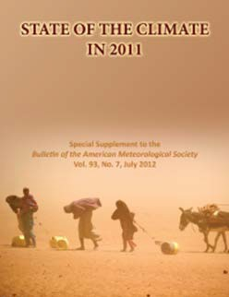

NCDC Scientist Co-Edits Paper Examining the Extreme
Events of 2011 from a Climate Perspective

NCDC scientist Dr. Thomas Peterson along with colleagues from the UK Met Office Hadley Centre and NOAA’s Of-
fice of Program Planning and Integration edited a paper entitled “Explaining Extreme Events of 2011 from a Climate Perspective.” The paper http://dx.doi.org/10.1175/BAMS-
D-12-00021.1 was published in the Bulletin of the American Meteorological Society and explains how the odds of six different extreme events of 2011 have changed in re-
sponse to global warming. Interestingly, the article showed that long-term climate change had no role in the 2011 flooding in Thailand, revealed a decreased likelihood of the cold UK winters like the one in 2010/2011, but concluded increased probabilities of several other events such as the
2011 droughts in Texas and the Horn of Africa. By develop- ing the ability to put recent extreme weather or climate events into the longer-term context of climate change, sci- entists can provide the public with the information needed to make decisions about how to effectively minimize and prepare for the impacts of these variations and changes in the climate system.

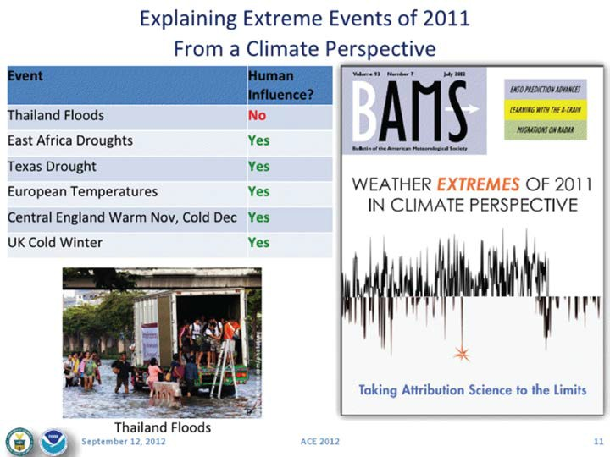

NCDC Facilitates Infrastructure for Global Drought
Monitoring Portal

NCDC leveraged existing information technology infra- structure built for the U.S. National Integrated Drought Information System (NIDIS) to integrate and provide access to global drought information. The United States volun- teered to develop a prototype Global Drought Monitor-
ing Portal from the lessons learned establishing the U.S. system.

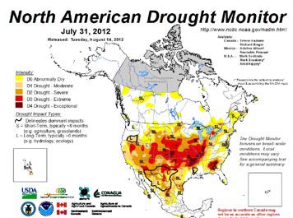

The North American Drought Monitor for July 31, 2012.
Drought Information System, which is the first step toward a Global Drought Early Warning System (DEWS). The intent of both the U.S. and Global Drought Portals is to address the critical lack of information related to water, food, and security, and to provide economic benefits by enabling ac- cess to products and data requested by various public and private organizations.

NCDC Transitions Three New Climate Data Records (CDRs)
to Operational Status in 2012

NCDC expanded the national inventory of eight opera- tional Climate Data Records (CDRs) to 11 by transitioning three new CDRs from research grade to operational status in 2012. The three new CDRs are Atmosphere Mean Layer Temperatures record, Sea Ice Concentration record, and the Snow Cover Extent record. Additionally, NCDC per- formed stewardship activities for the eight operational CDRs that were in place at the end of 2011 and developed software coding standards for the generation and sustain- ment of operational CDRs. These records provide input to emerging climate prediction modeling as well as capture and maintain the nation’s record of climate history, includ- ing the severity and frequency of drought, floods, and hurricanes. The CDRs provide trusted sets of information needed to enable improved protection of life, property, economic interests, and security. Produced from decades of satellite data and used by industry, government, and re- search communities to detect, assess, model, and predict

NCDC also coordinated with partners on four conti-
nents and in the Group on Earth Observation (GEO) and World Meteorologi-
cal Organization (WMO) to participate and contribute. The U.S. Drought Portal team solicited user require- ments, engaged interna- tional partners to obtain data and information, and
built an information technol-
ogy backbone to serve as
the global prototype. The
prototype grew and received
international cooperation
and buy-in, and was recently
recommended to form the
substructure of the Global





Climate Data Record Program: Serving the Public.

climate change, these long-term records also are valued by decision-makers to devise effective strategies to respond to, adapt to, and mitigate the impacts of climate variability and change. In order to produce CDRs, NCDC developed long-term, seamless homogeneous records characterizing climate change and variation. As new climate algorithms and sensor knowledge are developed, the entire period
of record is reprocessed to update the data. Further, although no standards existed for such long-duration soft- ware and algorithm maintenance, NCDC applied software engineering expertise and tailored existing standards and best practices. NCDC also devised new requirements to ensure that CDR software design and documentation can accommodate migration to future computing platforms and software languages.

NCDC Improves Global Surface Temperature Record

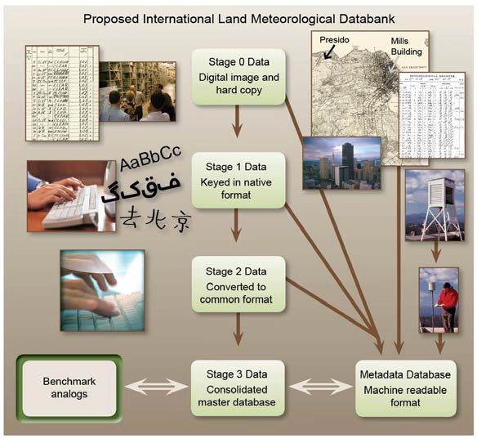
NCDC improved the global temperature record in 2012 by providing data and analyses of higher quality and by estab- lishing a new baseline
for reducing uncer- tainty in the global temperature record. Primary among those advances was the release of the first version of a new global databank of surface temperature data. This databank was developed as
part of the Interna- tional Surface Tem- perature Initiative, an effort led by NCDC
to improve data provenance, version control, openness and transparency, temporal and spatial coverage, as well as to develop methods
for merging disparate sources. At its most basic level, the effort has uncovered new sources of climate observations and brought the sources
together into a single consolidated dataset, thereby filling gaps in data, both temporally and spatially, and providing a more complete picture of the Earth’s climate from the
1800s to present. By integrating more than 40 sources of data into a single dataset, the databank brought the number of stations with mean monthly temperature to more than 35,000 from 7,280. Moreover, the new methods of data provenance as well as openness and transparency better ensure the integrity of the climate record and pro- vide a higher level of confidence in analyses for scientists and for public and private sector decision-makers.

NCDC Increases Data Holdings and Access of Data to
Users

NCDC gathers and archives data from all over the world. Throughout FY 2012, NCDC consistently advanced its data holdings and improved public access to its data. In FY
2012, visitors downloaded 1.9 petabytes of data, which is the equivalent of 25 years of HD-TV video and a 40-fold increase over the 47 terabytes of data downloaded just 7 years earlier (FY 2005). In comparison, FY 2011 recorded a total download of 1.285 petabytes. NCDC has also vastly increased its data holdings: A total volume of 9.9 petabytes was archived in FY 2012, which is an increase of more than
9 petabytes over the last 10 years. It would take almost
2.5 million DVDs, which would stack up nearly 10,000 feet
high, to hold 9.9 petabytes of data. Once the data is ar-
chived, NCDC employs state-of-the-art data management
techniques to provide these precise weather and climate
records to the public. As the world’s largest archive of cli-
mate data, NCDC’s vision is to be the most comprehensive,
accessible, and trusted source of climate and historical
weather data and information. NCDC enables its customers
to respond to the current and changing state of the climate
through open access to the center’s data holdings.
NCDC Fosters Understanding of Extremes and Climate
Change

In FY 2012, NCDC and the Cooperative Institute for Climate and Satellites-North Carolina (CICS-NC) hosted a series of workshops focused on bringing leading experts together
to discuss and analyze the state of science as it relates to extreme events and climate change. Analysis of climate extremes will benefit not only decision-makers but also society and the environment, potentially reducing the loss of life, property, and habitat. For example, since 1980 the United States has sustained well over 100 weather and climate disasters where damage from each exceeded $1 billion (U.S.). To ascertain the state of knowledge of such events, participants documented observed changes on multidecadal timescales, assessed the suitability of the underlying data, and explored the potential causes of any changes that had been observed. The first workshop fo- cused on climate hazards, including hurricanes, tornadoes and heavy precipitation. The second workshop focused on larger-scale events, such as heat waves, cold waves, floods and droughts. The third workshop addressed extratropi- cal storms, winds, and waves of the Northern Hemisphere, primarily during the cold season, with an emphasis on
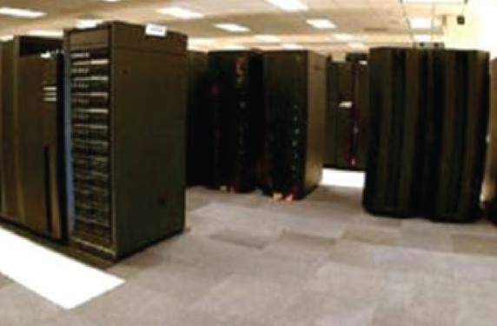
U.S. coastal regions. The intent behind each workshop was to advance the science by publish- ing a series of peer- reviewed papers in the Bulletin of the American Meteoro-
logical Society (BAMS). The paper from
the first workshop, entitled “Monitoring and Understanding Changes in Extreme Storm Statistics: State of Knowledge,” is available at http:// journals.ametsoc. org/doi/abs/10.1175/ BAMS-D-11-00262.1. The paper from the each of the second
and third workshops is currently under review at BAMS.

NCDC Uses Modern Archive Technology to Support High-Volume and Complex Datasets

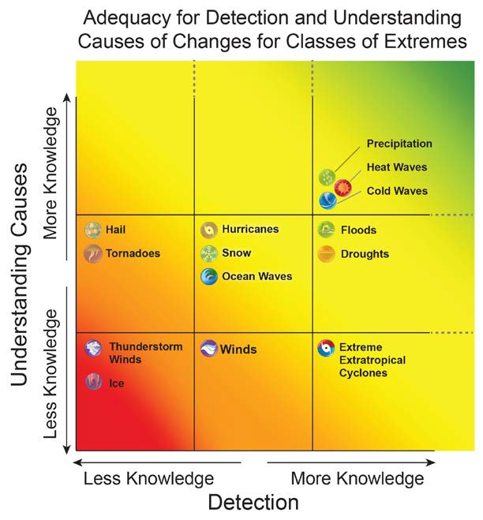

Authors’ assessments of the adequacy of data and physical understanding to detect and attribute trends. Phenomena are put into one of three categories of knowledge from less to more. The dashed lines on the top and right sides denote that knowledge about phenomena in the top category is not complete.

NCDC Team Enables Success of the Suomi National
Polar-orbiting Partnership Mission

NCDC’s Comprehensive Large Array-data Stewardship Sys- tem (CLASS) team led and participated in archive activities in support of the Suomi National Polar-orbiting Partner- ship (NPP), which is a joint NASA/NOAA satellite mission. Suomi NPP is the pathfinder or transition mission to the next generation of operational environmental satellites (Joint Polar Satellite System-JPSS) for the United States. CLASS is the sole designated archive for the mission’s data, and the team facilitated rigorous preparation for new
data flows, completed successful exhaustive pre-launch testing, and quickly established new data distribution mechanisms to meet NOAA’s and other interdepartmental agencies’ emerging post-launch needs. After launch, the excellent performance of CLASS encouraged new demands and requests for service that were placed on the system
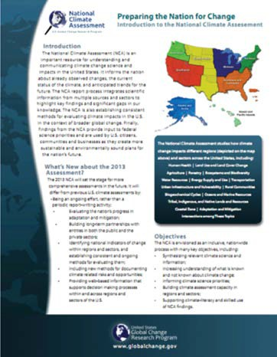
in response to critical needs for data flows from other NOAA offices and NASA project elements. The Suomi NPP mission’s data that reside in CLASS represent the latest polar-orbiting satellite technology and will extend NCDC’s considerable satellite climate data records.



NCDC Engages Partners to Support National and Regional
Climate Assessments

NCDC engaged NOAA’s Regional Climate Centers and external experts to contribute to and review the informa- tion in a suite of regional and national assessment climate scenarios that were developed, reviewed, and deployed in support of the National Climate Assessment (NCA) and ad- aptation planning. The scenarios to support the NCA are a more focused effort than in previous assessments, provid-
ing rigorous and consistent climate science underpinning as part of a commitment to a ‘sustained’ assessment en- deavor. This attention will assist in understanding plausible futures and in achieving a consistent base of climate infor- mation for each successive synthesis report. Envisaged and designed as both beneficial to the NCA process as well as directly beneficial to decision-makers intending to include climate information in their decision processes, these sce- narios incorporated eight regional reports and one nation- al report, and in combination represent over 600 pages,
650 images, and approximately 60 tables of information. Approximately 32 authors and an additional 24 contribut- ing authors provided information for the reports, which included observed climatologies and future projections as well as a full description of data sources used. The reports and the underlying maps, graphics, and metadata are avail- able to agency adaptation planning efforts, to the public, and to authors preparing the NCA. Through NCDC and the Climate Program Office, NOAA has been a lead agency in the 2013 NCA and in all previous assessment efforts.

NCDC Promotes Regional Drought Forums and Webinars

During 2012, NCDC Regional Climate Services Directors (RCSDs), in coordination with other NOAA offices and other partners substantially enhanced the nature and benefits
of drought information services by providing regionally specific details and opportunities to discuss impacts and response options with government and private-sector decision-makers charged with responding to the drought. In an effort to provide climate services information and resources to the hard-hit central and southern U.S., the RCSDs delivered webinars and forums to connect regional and local stakeholders to climate services that attempt to equip and educate on the drought impacts. These venues brought together a range of weather and climate informa- tion providers, along with representatives from a broad cross-section of management and user communities and surrounding areas. The purpose was to assess the cur-
rent drought status, its historic nature, and the short- and long-term weather and climate outlooks for possible relief; identify key impacts from the drought on a range of physi- cal and socioeconomic systems; discuss the use of climate information, products, and services in response to this and previous droughts; and identify opportunities for improved response efforts in the future. NCDC’s drought and climate monitoring data and information products were vital to
the services provided for the regions. These interactions created an opportunity for NOAA’s climate services to expand their reach beyond its internal partners and have been the springboard for new partnerships with state and
local governments as well as with other Federal agencies. Feedback from the sessions included positive comments regarding the clarity of the information provided and the timely delivery by the presenters. Inquiries for more infor- mation as well as invitations to speak at other events were also generated from these sessions.

NCDC Commissions New Component of U.S. Climate
Reference Network (USCRN)

NCDC, which is responsible for operation of the USCRN, completed the addition of soil moisture and temperature sensors as well as relative humidity sensors in 2011, and the new component system was commissioned at all 114 network sites in the conterminous United States in 2012. NCDC worked to implement a sustained soil and relative humidity monitoring program as part of its overall climate monitoring efforts. The new sensor program add-on was
necessary because traditional USCRN above-ground instru- mentation lacked the sub-surface soil observation compo- nents of moisture and temperature, which are very impor- tant for understanding climate and drought. The USCRN now provides the continuous monitoring of soil conditions across the conterminous United States and has recently begun expanding the installation of those soil sensors at
the current total of 12 stations in Alaska. This effort is all
in support of the National Integrated Drought Information
System (NIDIS), which synergizes with an overall U.S. and
North American drought monitoring effort led by NCDC.
Drought and other climate extremes have the potential of

increasing in frequency and/or magnitude
in the future, making the provision of this
soil and relative humidity data critical to
advancing the scientific understanding of
drought. Capturing the data will allow the
USCRN program and NCDC to better char-
acterize the climate conditions that exist
and to provide the information to water
resource managers, farmers, and scientists.
The management of ensuring the installa-
tion of these sensors and their continued
maintenance, coupled with the ability
to have programming and scientific staff
devoted to analyzing the data, is a great
addition to the overall study of climate and
greatly enhances the success of this effort.

David Brown, NCDC Regional Climate Service Director-Southern Region (standing), oversees one of several Drought Forum workshops held during the summer 2012.

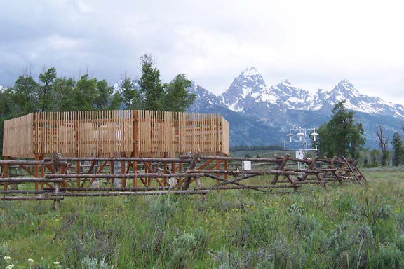

USCRN station photo of WY Moose 1 NNE located in Grand Teton National Park. Site photo was taken on June 22, 2005.

Online and Operational
Service

http://www.ncdc.noaa.gov/


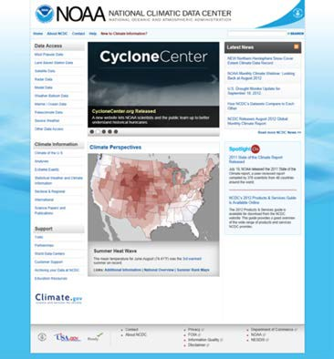
The National Climatic Data Center (NCDC) maintains an Internet World Wide Web (WWW) home page service, releasing a redesigned version in September of 2012. The website redesign creates a more inviting entry point to NCDC’s vast products, services and archives, in addition to offering a more intuitive way to access the Center’s many datasets and products. Some of the datasets and products available are highlighted in the following pages.

Our Web system includes access to U.S. and global climatic data, model data, satellite data, radar images, inventories of datasets available off-line, publications, climate moni- toring reports, special reports on extreme weather events, and an online ordering system. Just over 1,900 terabytes (1.911 petabytes) of data and information were download- ed by our customers during the 2012 fiscal year.

Several useful quick links are listed here, with these and others being described further in the following pages.
NOAA Virtual Data System (NVDS) Climate Data Online
Version 2 (CDO) –
http://www.ncdc.noaa.gov/cdo-web/search
The latest version implemented many new capabilities and
features.

Our most popular products— http://www.ncdc.noaa.gov/most-popular-data A listing of our top 20 products and datasets

Our Online Store—
http://www.ncdc.noaa.gov/online-store While online data are now free, NCDC’s Online Store provides the ability to order those offline items such as DVDs, posters, etc.

NOAA Climate Services Portal —
http://www.climate.gov/#dataServices
A completely revamped Data and Services section of the Portal, with integrated map services and new search capabilities.

The Nationa Cl matic Data Center (NCDC) ma nta ns an

Web Navigation
l i i i

NCDC released a redesigned version of its website, www.ncdc.noaa.gov, in September 2012. Modeled after NOAA’s site, the revamped homepage creates a more inviting entry point to NCDC’s vast products, services, and archives, in addition to offering a more intuitive way to access the Center’s many datasets and products. In the coming year, NCDC plans to incorporate all of its existing webpages into the new content management system to create a fully integrated website.
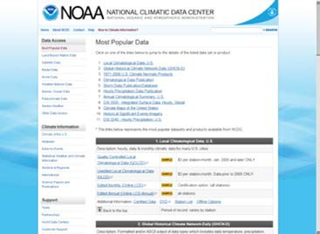
Data access and climate information are the two main hubs of the homepage, and you may find it helpful to use the search functionality at the top of the page to look for specific datasets or information. Suggested means of accessing our online data are detailed within the following pages.

Most Popular Products (MPP):
All NCDC online data are now provided at no charge to all users. NCDC’s Most Popular Products Web page at http://www.ncdc.noaa.gov/most-popular-data
provides access to a wide range of the most commonly requested publications and digital data products. From here you can access all major publications, CD-ROMs, digital datasets.

Land-Based Data
Land-Based (in situ) observations are collected from instruments sited at locations on every continent. They include temperature, dew point, relative humidity, precipitation, wind speed and direction, visibility, atmospheric pressure, and
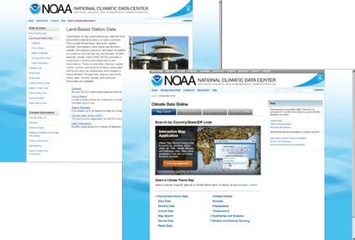
types of weather occurrences such as hail, fog, and thunder. NCDC pro- vides a broad level of service associated with in situ observations. These include data collection, quality control, archive, and removal of biases as- sociated with factors such as urbanization and changes in instrumentation
through time. Data on sub-hourly, hourly, daily, monthly, annual, and multi-year timescales are available through the Climate Data Online sys- tem at http://www.ncdc.noaa.gov/cdo-web/

Example data products:
Local Climatological Data, U.S. Hourly Precipita- tion, Global and U.S. Integrated Surface Hourly Data, Cooperative Data, etc.

Satellite Data

The National Oceanic and Atmospheric Administration
(NOAA) manages a constellation of geostationary and
polar-orbiting meteorological satellites. These satellites are distributed among three operational programs: the Suomi NPOESS Preparatory Project (NPP), the Geostationary Op- erational Environmental Satellite Program (GOES), and the Polar Operational Environmental Satellite Program (POES).

The Defense Meteorological Satellite Program (DMSP) satellites are operated by the U.S. Department of Defense and the data are archived and distributed by NOAA’s NCDC under the Shared Processing Program. Access to the most popular satellite data is through the Comprehensive Large Array-data Stewardship System (CLASS) at www.class.noaa.gov
contain four, five, six, or ten minutes of base data depend- ing on the volume coverage pattern. There are 41 Level-III products routinely available from NCDC, including precipi- tation estimates, storm relative velocity, and echo tops.

Example data products: Raw radiance data from instuments (POES Level 1b, GOES GVAR, DMSP TDR, etc.) and various satellite products, imagery, movies, and animations.

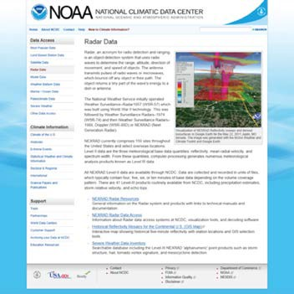

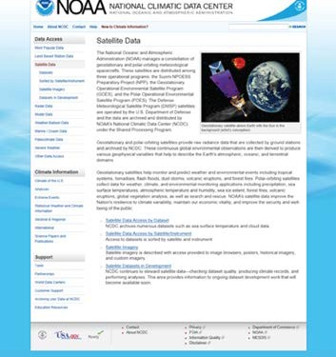
http://www.ncdc.noaa.gov/satellite-data
http://www.ncdc.noaa.gov/radarl-data

Radar Data

All NEXRAD Level-II data are available through NCDC. Data are collected and recorded in units of files, which typically
Example data/information: Visualization tools, decoding software, radar data access system, storm events, etc.

Model Data

The NOAA Operational Model Archive and Distribution System (NOMADS) project is a repository of weather model output datasets, model input datasets (assimila- tion), and a limited subset of climate model datasets gen- erated by NOAA. NCDC provides near-real-time access to
these weather model forecast data in addition to historical
model data.

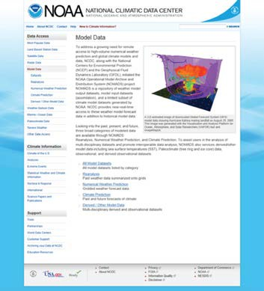

http://www.ncdc.noaa.gov/model-data

Example data products: Model Datasets, reanalysis, cli-
mate prediction, derived, etc.

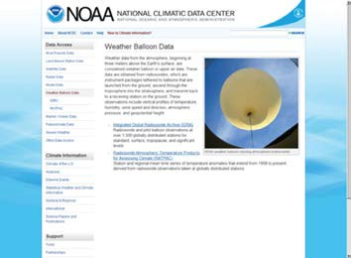

http://www.ncdc.noaa.gov/weather-balloon-data

Weather Balloon Data

Weather data from the atmosphere, beginning at three meters above the Earth’s surface, are considered weather balloon or upper air data. These data are obtained from ra- diosondes, which are instrument packages tethered to bal- loons that are launched from the ground, ascend through the troposphere into the stratosphere, and transmit back
to a receiving station on the ground. These observations include vertical profiles of temperature, humidity, wind speed and direction, atmospheric pressure, and geopoten- tial height.

Example data products: Upper Air Charts, NOAA Opera- tional Model Archive and Distribution System (NOMADS), Integrated Global Radiosonde Archiv (IGRA), etc

Marine / Ocean Data

NCDC receives and archives meteorological data
from ships at sea, moored and drifting buoys, coastal stations, rigs, and platforms. The temporal fre- quency of the observations range from sub-hourly to
6-hourly synoptic and are global in spatial coverage.

Example data products: International Comprehen- sive Ocean-Atmosphere Data Set Project (ICOADS), Global Buoy Data, Voluntary Observing Ship Climate Project (VOSClim), etc.

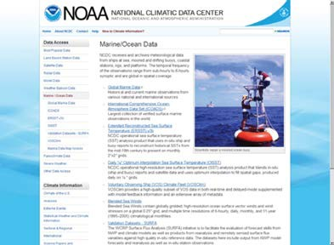

http://www.ncdc.noaa.gov/marineocean-data

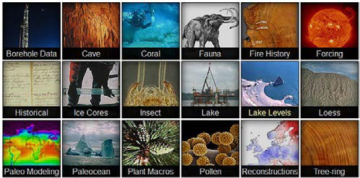
Paleoclimatology Data

http://www.ncdc.noaa.gov/paleoclimate-data
Paleoclimatic, or past climate
and environmental data, derived
from natural sources such as tree
rings, ice cores, corals, and ocean
and lake sediments extend the
archive of weather and climate
back hundreds of millions of years.
These data include geophysical or
biological measurement time series
and some reconstructed climate
variables such as temperature and
precipitation.

Example data/information: Paleoclimatology Proxy Data, Climate Reconstructions, Climate Model output, and Cli- mate Synthesis products.

Severe Weather

Severe weather is defined as a destructive storm or weather. It is usually applied to local, intense, often damaging, storms such as thun- derstorms, hail storms and torna- does, but it can also describe more widespread events such as tropical systems, blizzards, nor’easters and derechos.

Example data/information: Storm Events Database, Severe Weather Data Inventory (SWDI), IBTrACS.

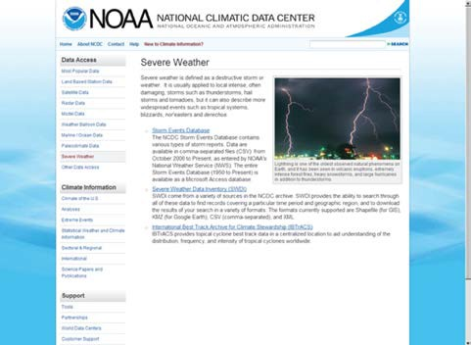

http://www.ncdc.noaa.gov/severe-weather

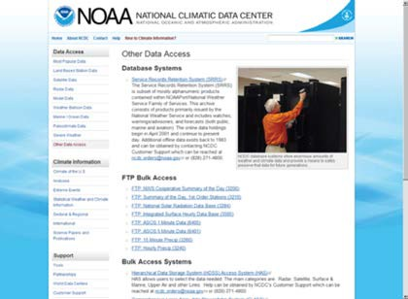

http://www.ncdc.noaa.gov/other-data-access

Other Data Access

NCDC provides links to other data and access systems that can be easily reached from this web page. Services and systems include Ser- vice Record Retention System (SRRS), FTP bulk data access, Hierarchical Data Storage System (HDSS), HAS, etc.

NOAA National Data Centers Online Store

Online Store

NCDC’s online data are now free to all users; however, we have a variety of items such as CD-ROMS, DVDs, posters, etc., that may be ordered and paid for online through our online store. Also, certified copies of
pdf data requested through the Cli- mate Data Online (CDO) system may be ordered through the online store. The Online Store also provides service for our partner Data Centers The National Oceanographic Data: Center (NODC) and the National Geophysical Data Center (NGDC)

Direct entry page to the Online Store:

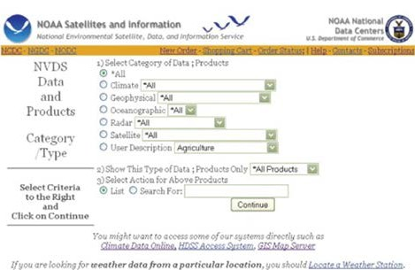

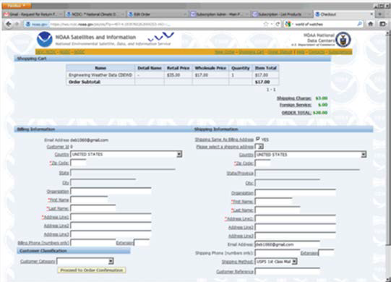

https://nes.ncdc.noaa.gov/plnes/plsql/olstore.main?look=1

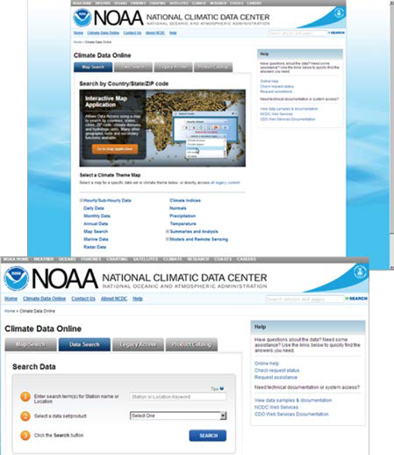
Climate Data Online (CDO) system

NCDC significantly changed access to climate data in recent months by retiring old datasets and systems and making new ones available. Climate Data Online (CDO) version 2.0 was released in December 2011
with three primary entry points for data ac- quisition: data search, dynamic maps, and web services. All three of these methods have an integrated underlying data model, which allows development of a consistent user interface and provides access to all products and services through a single system. Over the coming months, NCDC
will continue to transition more datasets and systems to the new acquisition service. The scope of data archived and serviced at NCDC not only includes products related to global in situ station data, but also balloon, radar, satellite, and model data. Our goal
is to provide users a consistent approach to data discovery across all of these data networks.

The data search functionality allows users to search by common station name, station identifier, zip code, country, county, state, or hydrologic unit. The search results can
be categorized by either representing a single station or by location (a group of stations). For example, a search on “Charlotte, NC” will return results showing stations and locations that match the search term. Users can then filter or sort the results to meet their needs. Users can select stations or locations, data types, and a time range of inter- est and order the data in CSV, ASCII text, and PDF output forms.

By means of dynamic mapping applications, users can visually discover NCDC data through a Geographic Infor- mation System (GIS). As a starting point, maps display the station distribution of the various data networks archived at NCDC. Users can display these stations by the frequency of collection or summarization (hourly/sub-hourly, daily, monthly, or annually) or by climate theme (temperature, precipitation, drought, snowfall). A number of tools allow users to select stations by location (country, state, county, zip code, hydrologic unit), by freehand (rectangle/polygon),

http://www.ncdc.noaa.gov/cdo-web/

by proximity from a point, or by gazetteer (geographic name search). The user can also order the data from the resulting station search.

NCDC constructed CDO Web services in a “RESTful” style, allowing users to write their own client software to access NCDC datasets. Users who have limited and well-defined data requirements will benefit from this type of access. These services do not replace bulk data download, which
is available through File Transfer Protocol (FTP). See http://
www.ncdc.noaa.gov/cdo-web/webservices for details.

CDO version 2.3 was released in the fall of 2012 with ad- ditional data products and features. Future releases will in- clude advanced searching and filtering capabilities, tighter map/search integration, and additional datasets, products, and services.

In Situ Data

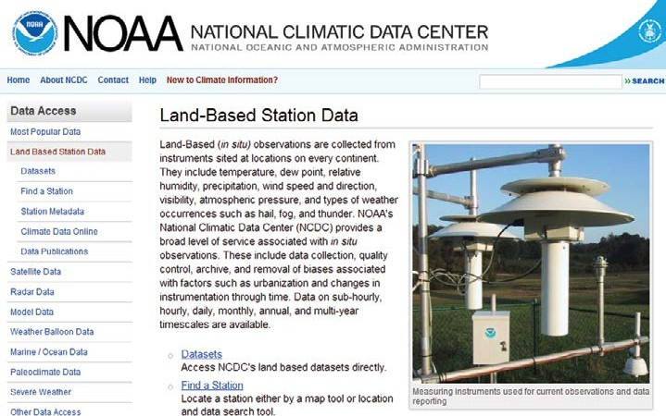
http://www.ncdc.noaa.gov/land-based-station-data

General Information

1. The periods of record for these datasets vary consider-
ably depending on data type and station.
2. All references to QC pertain strictly to data checking
and corrections performed within the Federal Climate
Complex. Other gross QC is usually performed at the
point of origin such as NCEP and AFWA.
3. The media available are: CD-ROM, DVD, and FTP
transfer. These options vary depending on the dataset.
4. Cost to customer varies depending on data volume
and the processing required for order.
5. This is only a summary of the major digital datasets
available from NCDC. Many other datasets/data types

(in addition to those listed below) are available. See http://www.ncdc.noaa.gov/doclib for a complete list and documentation for datasets.
6. NCDC’s website at http://www.ncdc.noaa.gov has links to numerous online datasets and data inventories. NCDC makes frequent updates to its website; users are encouraged to review it periodically.
7. Points of contact for information, cost estimates, and data requests: National Climatic Data Center, User Engagement & Services Branch, 151 Patton Avenue, Asheville, NC 28801-5001. Phone: 828-271-4800, Fax:
828-271-4876; Email: ncdc.orders@noaa.gov

• DATASET: Worldwide surface observations (hourly/
synoptic) --DSI3505–Integrated Surface Data (ISD)-
-worldwide stations.
• Data Type: ASCII character data.
• Quality Control: Extensive automated QC (all data); ad-
ditional manual QC for USAF, Navy, and NWS stations.
• Data Origin: An integration of data from numerous
sources, comprising all stations available historically.
• Content/Elements: About 20,000 stations currently
active. Includes wind speed and direction, wind gust,
temperature, dew point, cloud data, sea level pressure,
altimeter setting, station pressure, present weather, visibility, precipitation amounts for various time periods, snow depth, and various other elements as observed by each station; Observational practices vary by country.
• Period of Record: 1901 to present (varies greatly by station). See http://www.ncdc.noaa.gov/doclib for further details. The complete dataset for 1995-1999
is available with annual updates for all stations for the period 2000-2012. Online – http://www.ncdc.noaa. gov/cdo-web/search

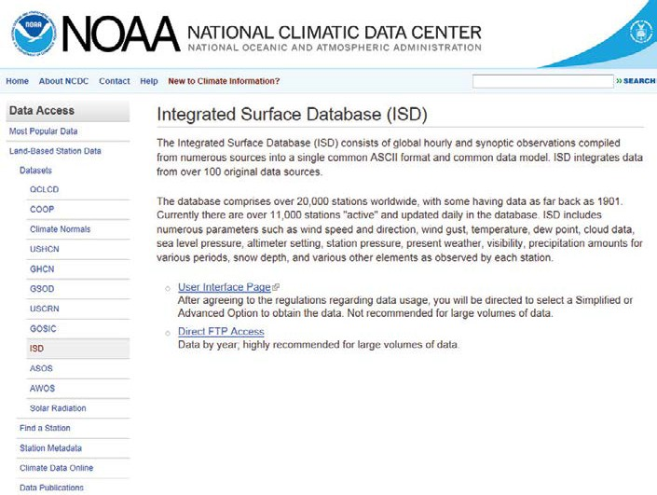
http://www.ncdc.noaa.gov/land-based-station-data/integrated-surface-database-isd or via FTP at ftp://ftp.ncdc.noaa.gov/pub/data/noaa/

DATASET: Global ship and buoy observations (hourly/ synoptic). The International Comprehensive Ocean Atmo- sphere Data Set (ICOADS) and NCDC Global Marine Data.
• Data Type: ASCII character data.
• Quality Control: Undergoes automated QC.
• Data Origin: Data originate from Global Telecom
munications Systems (GTS) + some key-entered
data.
• Content/Elements: Includes elements observed
by ships, buoys and Coastal Marine Automated
Network (CMAN) stations--temperature and dew
point, wind direction and speed, visibility, present
weather, sea level pressure, sea surface tempera
ture, cloud data, ice data, and wave/swell heights
and periods; Generally, buoys and CMAN stations
only observe temperature, wind, pressure, sea
surface temperature, and wave/swell data; while
some ship reports include other elements;
Elements vary considerably by station.
• Period of Record: As early as 1662 to present.
• Notes: See http://www.ncdc.noaa.gov/doclib for
further details.
• Online: http://www7.ncdc.noaa.gov/CDO/CDOMa
rineSelect.jsp & http://has.ncdc.noaa.gov/pls/
plhas/HAS.FileAppSelect?datasetname=1173 ICO
ADS Release 2.5 (1662-2007) augmented by pre-
liminary Near-Real-Time (NRT) extensions
(2008-present) is available in monthly files via
NCDC ftp access. These observations can be
retrieved from the following location: ftp://ftp.
ncdc.noaa.gov/pub/data/icoads2.5/.
For information on the ICOADS R2.5 monthly files, please read the following file prior to using the data: http:// www1.ncdc.noaa.gov/pub/data/icoads2.5/Documenta- tion/R2.5-README_ICOADS_NCDC_20120215.pdf

Beginning sometime during 2013, NCDC will offer a new ICOADS NRT product consisting of a blend of NCDC and the National Centers for Environmental Prediction (NCEP) Ma- rine Surface Global Telecommunication System (GTS) ob- servations. The new product will merge the two streams, remove duplicates, and retain all unique and best duplicate observations for a more complete dataset.

For official ICOADS data access at NCDC, the user must select data type “icoads2.5.” NCDC offers only “enhanced” R2.5 observations, which were derived using 4.5 standard deviation “trimming” (quality control screening) limits, so as to accommodate more extreme climate events, and using a broad collection of marine observations includ-
ing ships, buoys and near-surface oceanographic profile temperatures. All three U.S. ICOADS Partners (NOAA/ESRL, NOAA/NCDC, NCAR) offer various data access and format options. To review all available options, please see the ICO- ADS Products Website at http://icoads.noaa.gov/products. html, under the “Observations” section.

For general ICOADS information, please visit the ICOADS
home page at http://icoads.noaa.gov/index.shtml.

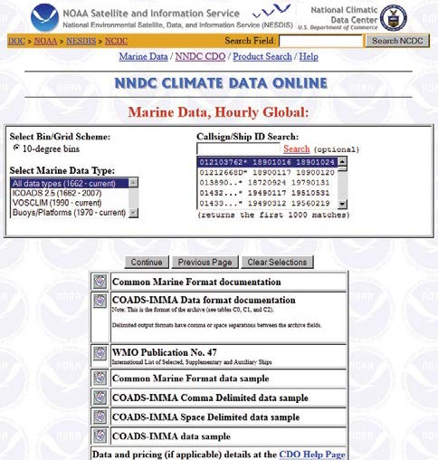

http://www7.ncdc.noaa.gov/CDO/CDOMarineSelect.jsp

DATASET: Global ship observations (hourly/synoptic).
Voluntary Observing Ship Climate (VOSClim) Project.
• Data Type: ASCII character data.
• Quality Control: Undergoes automated QC;
additional QC is performed by the UKMET Office
against corresponding model fields.
• Data Origin: Data originates from Global Tele
communications Systems (GTS) + some key-
entered data.
• Content/Elements: Includes elements observed
by ships--temperature and dew point, wind direc-
tion and speed, visibility, present weather, sea
level pressure, sea surface temperature, cloud
data, ice data, and wave/swell heights and peri-
ods; Background model fields for sea level pres- sure, air temperature, sea surface temperature, winds and relative humidity are also included.
• Period of Record: 2001 to present.
• Notes: See http://www.ncdc.noaa.gov/oa/docu
mentlibrary/vosclim/imma.pdf for data format
details.
• Online: Fleet Ship List: http://www1.ncdc.noaa.
gov/pub/data/vosclim/ vosclimshiplist.xls
Monthly ASCII Files: http://www.ncdc.noaa.gov/oa/
climate/vosclim/vosclimdata.html
Database Access for subsetting Purposes: http://www7.
ncdc.noaa.gov/CDO/CDOMarineSelect.jsp

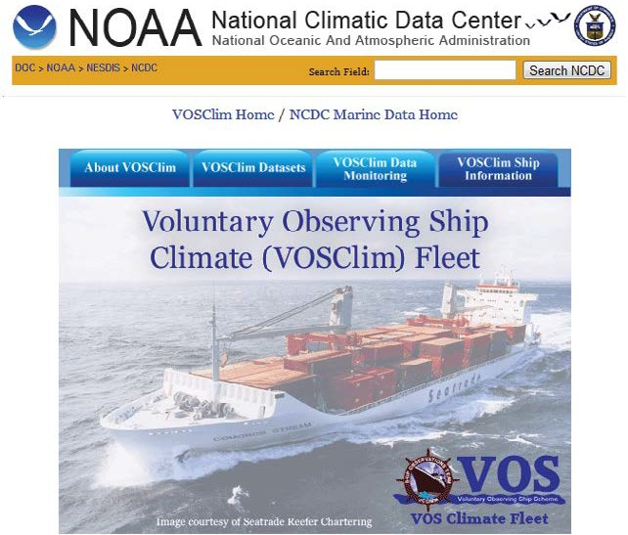
http://www.ncdc.noaa.gov/oa/climate/vosclim/vosclim.htm

DATASET: Hourly precipitation data for NWS and coop- erative U.S. stations--DSI3240.
• Data Type: ASCII character data.
• Quality Control: Undergoes automated and
manual quality control.
• Data Origin: Various sources including ASOS and
punched tape from stations.
• Content/Elements: Hour-by-hour precipitation
amounts; About 2,800 stations currently active.
• Period of Record: Generally 1948 to present.
• Notes: See http://www.ncdc.noaa.gov/doclib for
further details. Data are also available on a CD-
ROM set.
• Online: http://www.ncdc.noaa.gov/cdo-web/
search

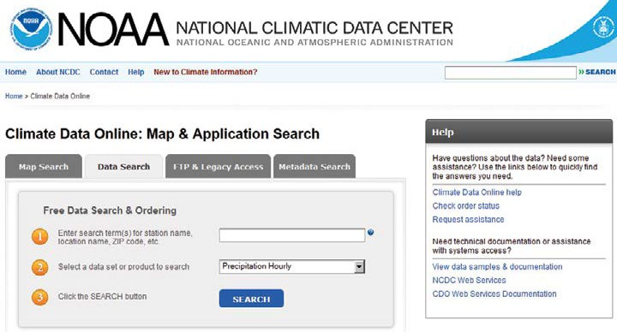
http://www.ncdc.noaa.gov/cdo-web/#t=secondTabLink

DATASET: 15-Minute precipitation data for NWS and
Cooperative U.S. stations-¬DSI3260.
• Data Type: ASCII character data.
• Quality Control; Undergoes automated and
manual QC.
• Data Origin: Various sources including ASOS and
punched tape from stations.
• Content/Elements: Precipitation amounts for
15-minute increments; About 2,400 stations currently active.
• Period of Record: Generally 1971 to present.
• Notes: See http://www.ncdc.noaa.gov/doclib for
further details.
• Online: http://www.ncdc.noaa.gov/cdo-web/
search

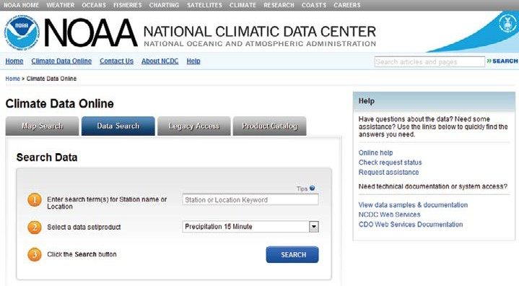

http://www.ncdc.noaa.gov/cdo-web/#t=secondTabLink

DATASET: United States Historical Climatology Network
(USHCN).
• Data Type: ASCII character data.
• Quality Control: Monthly mean maximum, minimum
and average temperature and total precipitation are
quality controlled. Temperature data are bias correct
ed to remove non-climatic artifacts associated with
station moves and changes in observer practices, in
strumentation and environment that occur through
time.
• Data Origin: NOAA Cooperative Observer Program
(COOP) Network Data.
• Content/Elements: USHCN stations comprise a subset of the NOAA Cooperative Observer Program (COOP) network that have been selected based on spatial coverage, record length, data completeness and historical stability; As of October 2012, USHCN Version
2.5 replaced version 2.0, incorporating modifications to the underlying database as well as coding changes to the pairwise homogenization algorithm (PHA) that improve its overall efficiency.
• Period of Record: The dataset consists of 1,218 stations with Periods of Record generally 1895 to present.
• Online: http://www.ncdc.noaa.gov/oa/climate/re
search/ushcn/

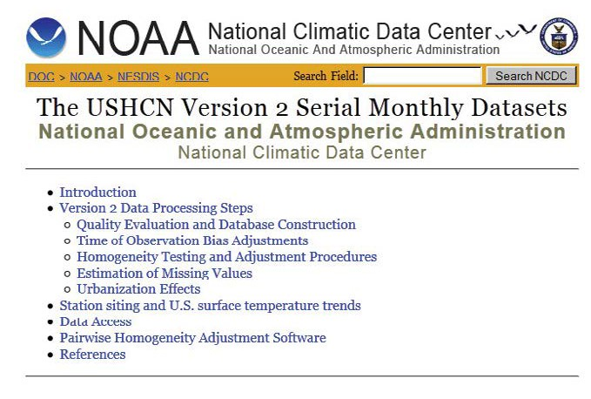
http://www.ncdc.noaa.gov/oa/climate/research/ushcn/

DATASET: Global Historical Climate Network-Daily (GHCN- Daily) – Summary Of the Day (SOD) Data from NOAA’s National Weather Service (U.S.), Community Collabora- tive Rain, Hail and Snow Network {CoCoRaHS (U.S.)}, De- partment of Defense (U.S. and Foreign) and Global Sites.
• Data Type: ASCII character data.
• Quality Control: All datasets undergo automated
QC.
• Data Origin: Various sources including ASOS,
directly from stations, and key-entry.
• Content/Elements: Includes maximum/minimum
temperatures, precipitation, snowfall and snow
depth; Some U.S. stations have additional data such as evaporation and soil temperature;
Element content varies greatly by station; Approx- imately 28,000 stations are regularly updated; over 84,000 stations have available historical
data.
• Period of Record: Generally 1890s to present,
with the earliest observations beginning in the
1830s.
• Notes: See http://www.ncdc.noaa.gov/doclib for
further details.

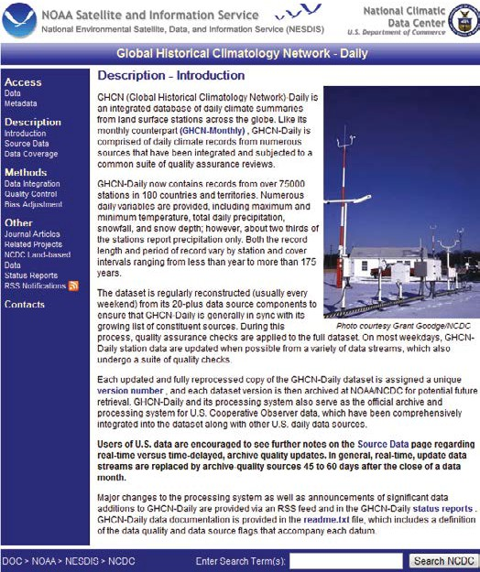
http://www.ncdc.noaa.gov/oa/climate/ghcn-daily/index.php

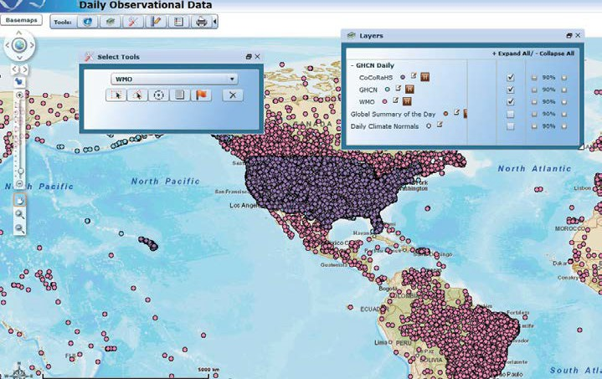

http://www.ncdc.noaa.gov/cdo-web/#t=firstTabLink (select ‘Daily Data’)

DATASET: NOAA’s 1981-2010 U.S. Climate Normals
• Data Type: ASCII character data.
• Quality Control: Undergoes some automated QC.
• Data Origin: Various sources including the GHCN-Daily
Dataset and Standardized Monthly Temperature Data.
• Content/Elements: The 1981-2010 U.S. Climate Nor-
mals provides available Climate Normals for over
9,800 stations and replaces the 1971-2000 U.S.
Climate Normals Product; 7,500 stations have Temper-
ature-related Normals; Precipitation Normals for
9,300 stations; Additionally, 6,400 stations have
Snowfall Normals, and 5,300 stations have Snow
Depth Normals; Hourly Normals for Wind, Pressure,
Cloud Cover, etc., are available for 262 stations. The
1981-2010 U.S. Climate Normals are available for data elements such as Temperature, Precipitation, Wind, Cooling and Heating Degree Days, Pressure, Cloud Cover, etc. Additionally, the periods of time available for this dataset include, but are not limited to Annual, Seasonal, Monthly, Daily and Hourly.
• Period of Record: 1981-2010.
• Notes: See http://www1.ncdc.noaa.gov/pub/data/nor
mals/1981-2010/readme.txt for further details regard
ing available files for the 1981-2010 U.S. Climate
Normals.
• Online: http://www.ncdc.noaa.gov/oa/climate/nor
mals/usnormals.html

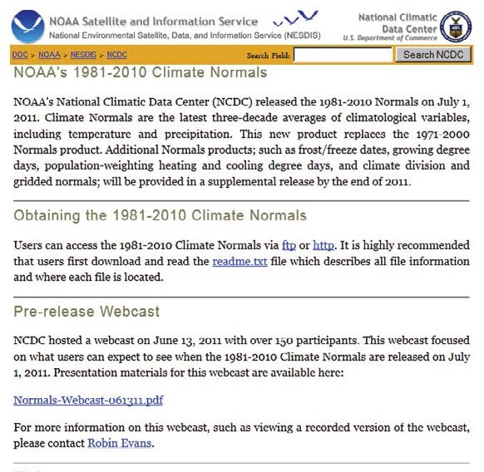
http://www.ncdc.noaa.gov/oa/climate/normals/usnormals.html

DATASET: Summary of month data for U.S. and global sites {Global Historical Climate Network (GHCN- Monthly)}.
• Data Type: ASCII character data.
• Quality Control: All datasets undergo automated QC.
• Data Origin: Various international sources. Updated
monthly primarily from CLIMAT messages.
• Content/Elements: Includes monthly mean tempera-
ture, monthly maximum/ minimum temperatures,
and monthly total precipitation; Element content
varies greatly by station; Approximately 20,000
stations with precipitation data and 7,280 stations with monthly mean temperature.
• Period of Record: Generally late 1800s to present, with the earliest observations beginning in the 1700s.
• Online: http://www.ncdc.noaa.gov/ghcnm/ Disclaimer: As of September 2012, the version of GHCN- Monthly for temperature variables is V.3.2; for precipita- tion variables, the version is v.2.0. The latest information about GHCN-Monthly Version Availability is accessible from the GHCN-Monthly Website. http://www.ncdc.noaa. gov/ghcnm/

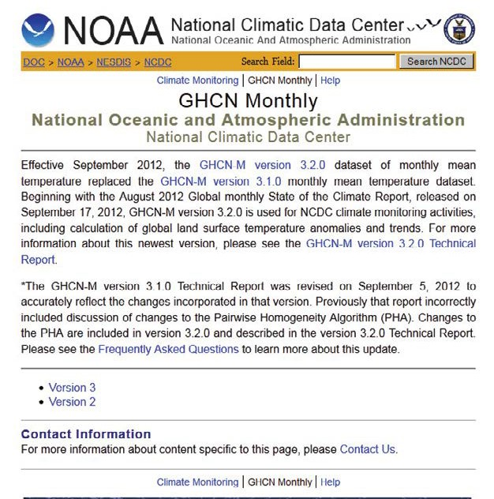
http://www.ncdc.noaa.gov/ghcnm

DATASET: National Solar Radiation Database 1991-2005 for the U.S., Guam, and Puerto Rico-¬DSI3284.
• Data Origin: National Renewable Energy Laboratory
(NREL)
• Content/ Elements: The 1991 – 2005 National Solar
Radiation Database (NSRDB) contains hourly solar
radiation (including global, direct, and diffuse) and
meteorological data for 1,454 stations. This update
builds on the 1961-1990 NSRDB, which contains data
for 239 stations. This includes the conventional time
series for NSRDB ground stations as well as a one-
tenth-degree gridded dataset that contains hourly
solar records for 8 years (1998 – 2005) for the United
States (except Alaska above 60° latitude) for about
100,000 pixel locations (at a nominal 10-km-by-10-km
pixel size).
• Period of Record: 1991 to 2005
• Notes: See ftp://ftp.ncdc.noaa.gov/pub/data/nsrdb-
solar/ solar-only/documentation/NSRDBusermanual.
pdf for further details
• Online: http://ols.nndc.noaa.gov/plolstore/plsql/ol
store. prodspecific?prodnum=C00668-TAP-A0001

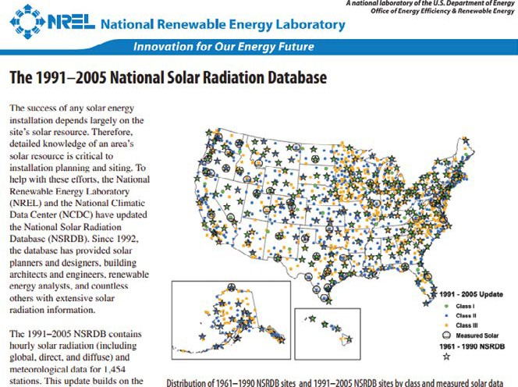

DATASET: ASOS 1-minute and 5-minute data DS16401-
6406.
• Data Type: ASCII character data.
• Quality Control: Undergoes automated QC.
• Data Origin: Data originate from ASOS ingest process.
• Content/Elements: Includes most surface elements
observed in the U.S. (wind speed and direction, tem-
perature, dew point, cloud data, sea level pressure,
altimeter setting, station pressure, present weather, visibility, precipitation amount, etc). About 900 sta- tions currently active.
• Period of Record: Generally 1998 to present (2000 to present online).
• Notes: http://www.ncdc.noaa.gov /doclib
• Online: http://www.ncdc.noaa.gov/oa/climate/cli
matedata.html#asosminutedata

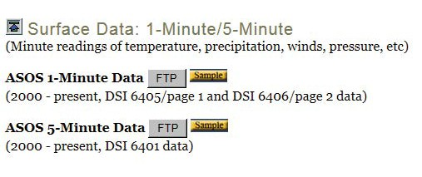
http://www.ncdc.noaa.gov/oa/climate/climatedata.html#asosminutedata

DATASET: Service Records Retention System (SRRS) data.
• Data Type: ASCII character and binary data.
• Quality Control: No quality control performed.
• Data Origin: Data originate from ingest of NWS products.
• Content/Elements: Includes: 1) all surface, upper-air,
forecast, warning, and other text bulletins received via SRRS
processes;2) many National Weather Service (NWS)/Na-
tional Centers for Environmental Prediction (NCEP) Model- Generated Charts and Analyses; and 3) the National Digital Forecast Database (NDFD).
• Period of Record: Late 2000 to present.
• Notes: These are the “raw” data as received from NCEP
and NWS.
• Online: http://nomads.ncdc.noaa.gov/ncep/NCEP

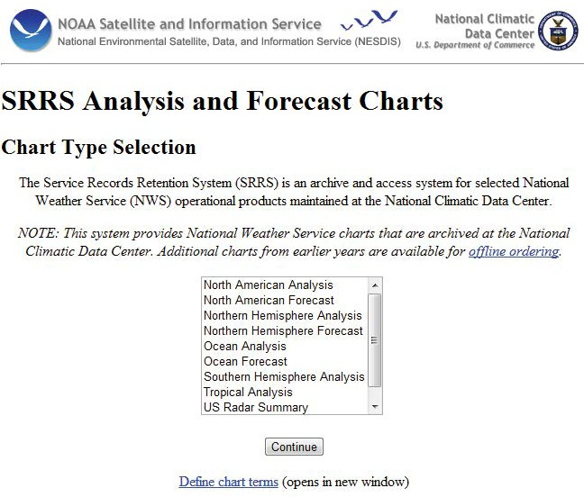
http://nomads.ncdc.noaa.gov/ncep/NCEP

DATASET: Worldwide upper-air observations–Integrated
Global Radiosonde Archive (IGRA).
• Data Type: ASCII character data.
• Quality Control: Undergoes some automated QC.
• Data Origin: Various sources including digital data
from the stations (U.S. plus some from Mexico), key-
entered data, digital data from source countries, and
GTS.
• Content/Elements: Replaced Comprehensive Aero-
logical Reference Dataset (CARDS)–DS 6305. Includes
all elements observed in upper air soundings—gen- erally temperature, dew point depression, atmospher- ic pressure, wind direction and speed. About 1,500 globally distributed stations; 900 of the stations are currently active.
• Period of Record: Generally 1938 to present.
• Notes: See http:// www.ncdc.noaa.gov/oa/climate/
igra/index.php for further details.
• Online: http://www.ncdc.noaa.gov/oa/climate/igra/
index.php

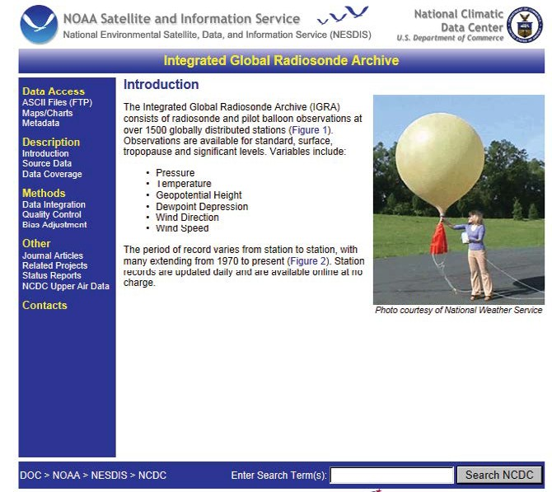
http://www.ncdc.noaa.gov/oa/climate/igra/index.php

DATASET: Historical Observing Metadata Repository (HOMR). HOMR is NCDC’s integrated Station History data- base that provides land-based station metadata in support of NCDC research, reporting, publications, data products and web applications.
• Content/Elements: Includes current and historical station metadata for various land-based networks when available. Details include station identifiers, names, location, elements, and equipment.
• Master Station History Report (MSHR): Digital listing of basic, historical identifier / location information for every station in the Station History database.
• Publication History Report (PHR): Digital compilation of elements observed and/or reported for all pub- lished stations in National Weather Service’s Coopera- tive network.
• Online - http://www.ncdc.noaa.gov/homr/
• Station History Visualization: Provides a graphical
overview of station-level metadata attributes and
their changes over time.

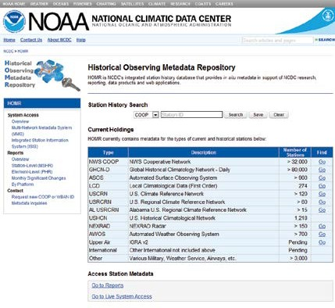
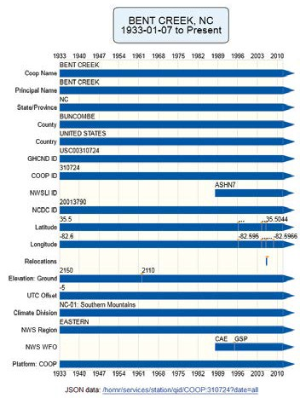
http://www.ncdc.noaa.gov/homr/

Specialized In Situ Products

General Information
These Specialized Products can be provided on CD/DVD or
as paper copy (unless otherwise indicated). Please call 828-
271-4800 or email “ncdc.orders@noaa.gov” for further
details. There are charges involved for these services.

Cooperative Station Extremes Tabulation: This tabulation shows daily and monthly extremes for the entire period of record (generally 1948 to 2010) for U.S. cooperative and National Weather Service sites. There are currently over
8,000 active stations. The elements included are maxi-
mum/minimum temperature, precipitation, and snowfall.

Wind Rose Summary: This summary provides a statistical summary of wind speed vs. wind direction for any station (U.S. or foreign) reporting adequate observational data. Data are tabulated in incremental ‘bins’ such as 0-3 miles per hour, 4-7 miles per hour, etc., and can be run for peri- ods of record through 2009.

Mixing Height Summary: This summary provides a day- by-day estimate of the mixing height for the boundary layer by using surface and upper air observational data.
It’s often used for pollution and air dispersion models. This product is provided for U.S. sites only and can be run for periods of record through 2009.

Stability Array: This provides month-by-month averages of surface-based stability in Pasquill stability categories. Hourly or synoptic surface observations are used as input and can be run for periods of record through 2009.

NEXRAD Products

NCDC archives and disseminates data from the Next Gen-
eration Weather Radar (NEXRAD) system. Comprised of
160 Weather Surveillance Radar to 1,988 Doppler (WSR-
88D) sites throughout the United States and select over-
seas locations, NEXRAD is a joint effort of the United States
Departments of Commerce (DOC), Defense (DOD), and
Transportation (DOT). The controlling agencies are the Na-
tional Weather Service (NWS), Air Force Weather Agency
(AFWA) and Federal Aviation Administration (FAA), respec-
tively. Level II data include the six meteorological base
data quantities: reflectivity, mean radial velocity, spec-
trum width, differential reflectivity, correlation coefficient
and differential phase. From these quantities, computer processing generates numerous meteorological analysis products known as Level III data. Level II data are recorded at all NWS and several select CONUS DOD WSR-88D sites. Level III products are recorded at 156 of the 160 sites.
All WSR-88Ds are expected to complete the modification to implement dual polarization capability in 2013. This new technology allows the WSR-88D to simultaneously transmit and receive in the horizontal and vertical planes, providing an additional dimension of weather features and giving the weather forecaster additional and improved tools to serve the public.



http://www.roc.noaa.gov/WSR88D/PublicDocs/DualPol/DPstatus.pdf http://www.roc.noaa.gov/WSR88D/PublicDocs/DualPol/DPSchedule.pdf

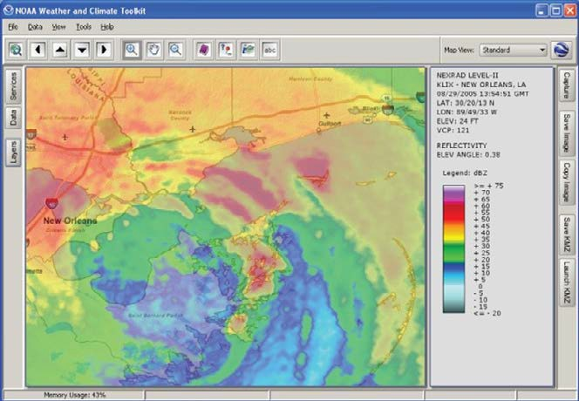

NEXRAD Level-II Base Reflectivity Image with ESRI background map

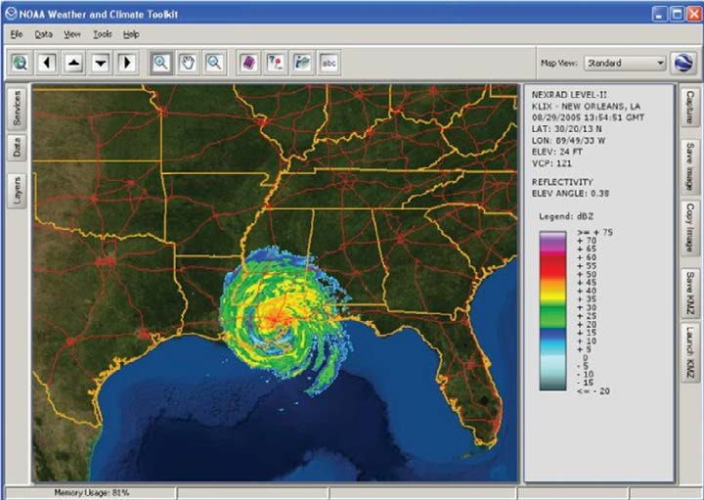

NEXRAD Level-II Base Reflectivity Image with ESRI imagery

A list of all NEXRAD Level III products, including the new dual polarization products, can be found at the following site:

http://www.ncdc.noaa.gov/oa/radar/radarproducts.html

NCDC provides a radar viewer and data export toolkit called NOAA’s Weather and Climate Toolkit. It is free soft- ware that visualizes WSR-88D Level-II and Level-III NEXRAD Radar data from NCDC’s Archives on Windows, Mac, and Linux platforms.
.

Hurricane Katrina: 3-D volume scan KMZ output rendered in Google Earth

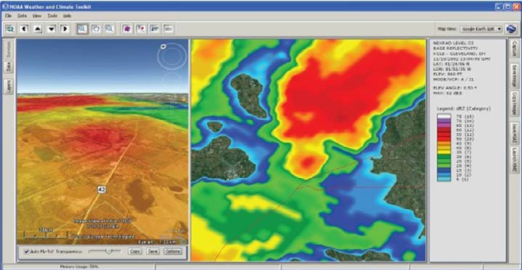

Level-III Base Reflectivity with internal Google Earth plug-in

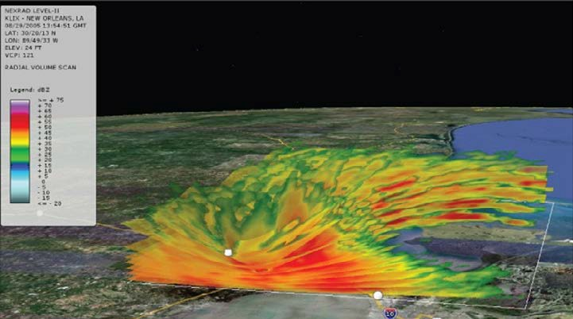

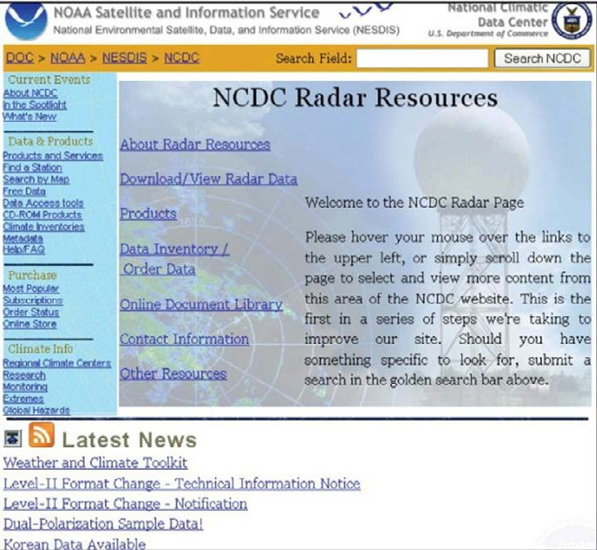

NCDC Radar Resources Web page http://www.ncdc.noaa.gov/oa/radar

The following two sites provide access to NEXRAD Level II and III data:
1) The NEXRAD Inventory and Ordering System:
http://www.ncdc.noaa.gov/nexradinv - this site is designed for ordering data for a specific day
and site using a simple interface.
2) The HAS system: http://has.ncdc.noaa.gov/- this site is designed for bulk orders and allows
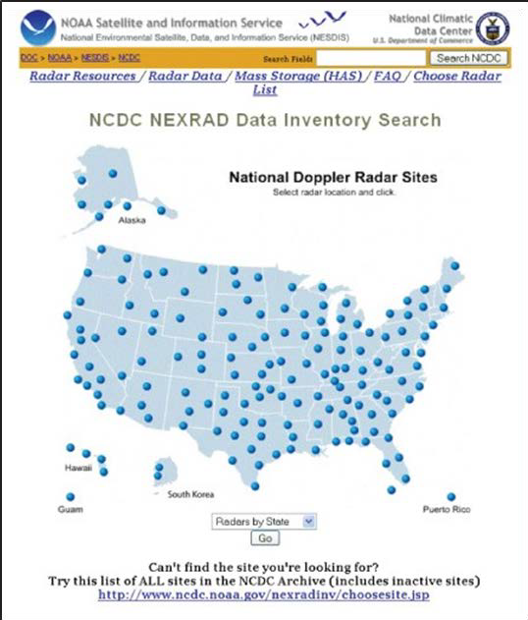
one year of data to be ordered at a time.

Website screenshot of http://www.ncdc.noaa.gov/nexradinv/

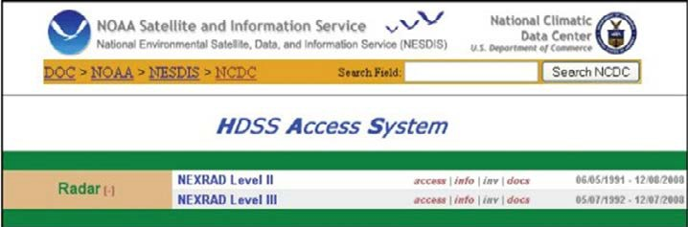

Website screenshot of http://has.ncdc.noaa.gov/

The Weather and
Climate Toolkit

can generate simple visualization and data export of weather and climatological data archived at NCDC. The Toolkit also provides access to weather/climate web services from NCDC and other organizations, as well as community standard data formats. The Viewer offers tools for displaying custom data overlays, Web Map Services (WMS), animations and basic filters. The export of im-
ages and movies is provided in multiple formats. The Data Exporter allows for data export in both vector point/line/ polygon and raster grid formats. Additional visualization capabilities include constant altitude slices of radial vol- ume scans and isosurface export to Google Earth.

Recent updates added support for:

• NEXRAD Dual-Polarization support (Level-II
moments and Level-III products)

• Isosurface export to Google Earth (KMZ format)

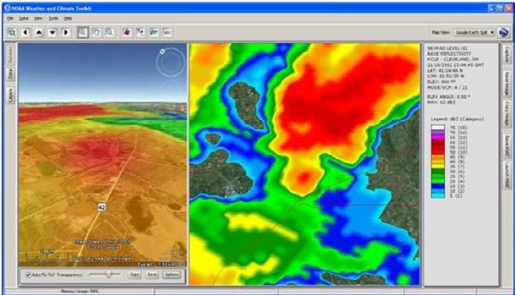
Example screenshots:
• CAPPI (Constant Altitude Plan Position Indicator) - a constant altitude cross-section of Radar data.

Current data types supported:

• NEXRAD Radar Data (Level-II and Level-III)

• GOES Satellite AREA Files

• Gridded NetCDF, OPeNDAP and HDF following
Climate-Forecast (CF) conventions.

• NCML (NetCDF Markup Language)

• GRIB, GINI, Gempak formats

Current data services:

• U.S. Drought Monitor Service (from the National
Drought Mitigation Center (NDMC)

Level-III Base Reflectivity with Google Earth plug-in

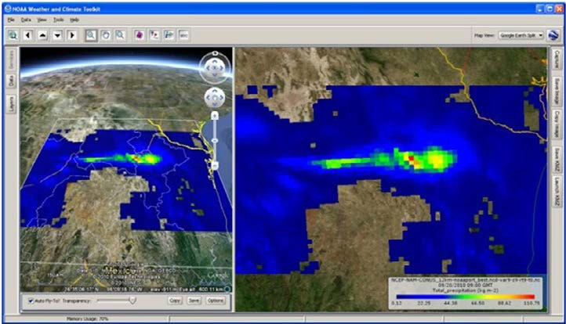
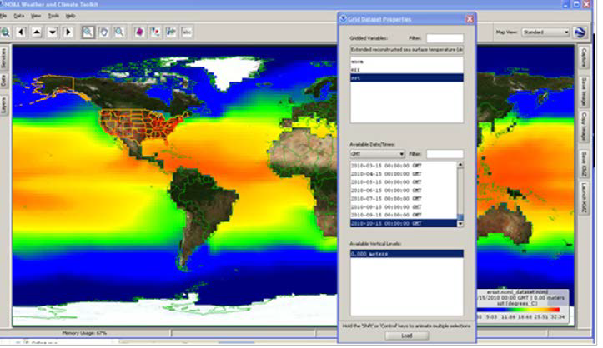
NCEP North American Model (NAM) spatial subset with Google Earth plug-in

Sea Surface Temperature (remote OPeNDAP dataset)

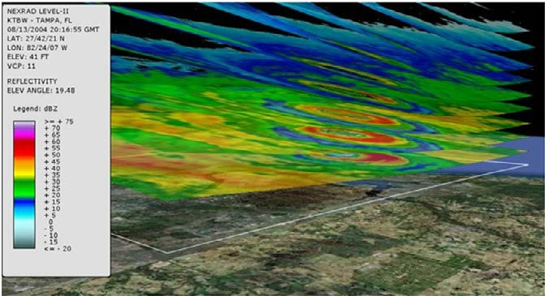
Hurricane Charley: 3-D volume scan KMZ output rendered in Google Earth

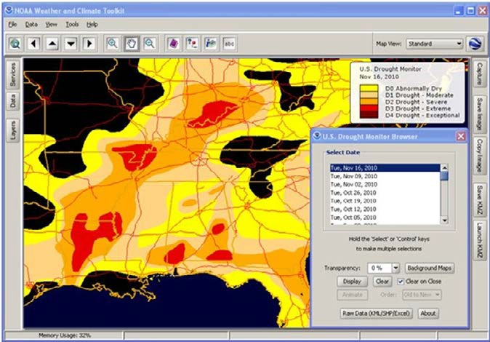
U.S. Drought Monitor—Web Map Service

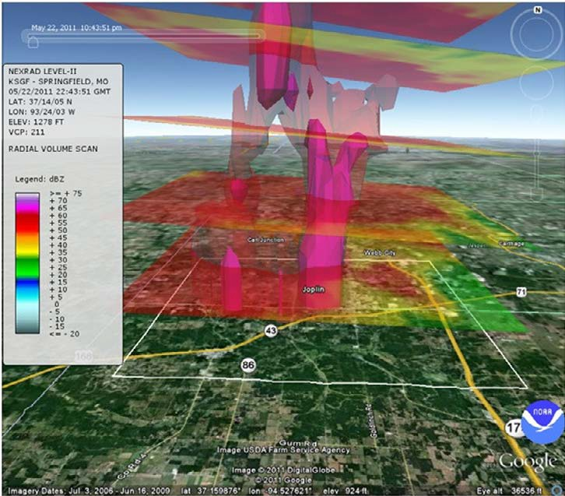
Isosurface visualization in Google Earth of May 22, 2011 Joplin, MO tornado

Satellite Data, Products
& Service

Satellite data and derived products from NOAA’s satel- lites are available through NOAA’s National Climatic Data Center (NCDC) and the Comprehensive Large Array-data Stewardship System (CLASS). NOAA’s three primary satel- lite systemsare the Geostationary Operational Environ- mental Satellite (GOES), the Polar-orbiting Operational En- vironmental Satellite (POES), and the new Suomi National Polar-orbiting Partnership (S-NPP). We also distribute data and products from the Defense Meteorological Satellite
Program (DMSP) and European Organization for the Ex- ploitation of Meteorological Satellites (EUMETSAT) Metop satellite. Follow the link

below to access the many new blended products in common data formats that have been developed for long-term climatological studies.

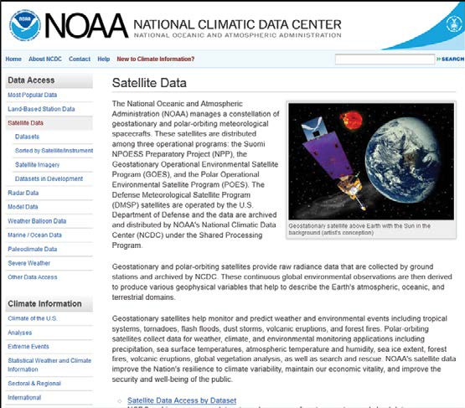
http://www.ncdc.noaa.gov/satellite-data

Online Satellite Data - Comprehensive Large Array-data
Stewardship System (CLASS)

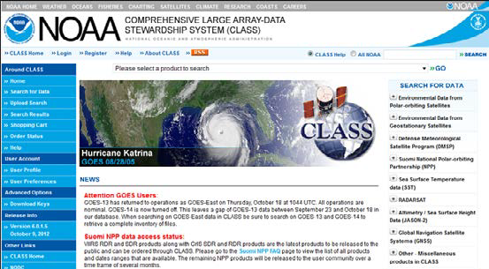
An IT component of the NOAA Data Centers, CLASS is an electronic library of NOAA environmental data. It enables users to perform collection level as well as granule level discovery and ordering of Level 0 through Level 3 satellite products observed and processed by NOAA, the Depart- ment of Defense Meteorological Satellite Program, and
EUMETSAT (MetOp-A and MetOp-B). Data delivery options include FTP, HTTP, and physical digital media. The former two options are free within the constraints pro- vided via the web interface. Subscription services for near real-time data and high-volume orders can be requested through
the CLASS Help Desk. A tutorial with step-by-step instruc- tions for ordering data from CLASS can be accessed from its home page. Below are a few views of the CLASS web system.

CLASS Home Page—www.class.noaa.gov

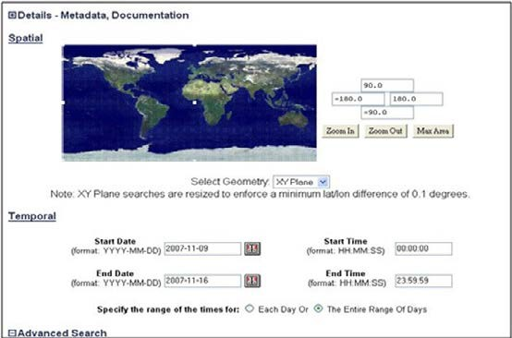
CLASS Search Criteria Page

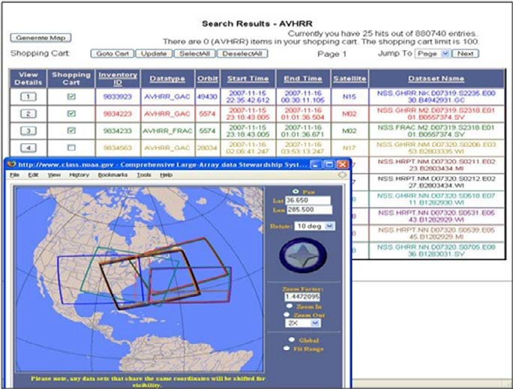

CLASS Search Results Page with Separate Map Window

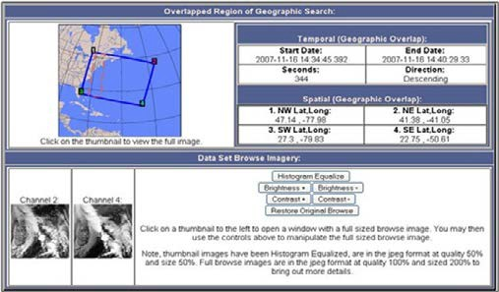

CLASS Detail Page showing Metadata and Browse Images

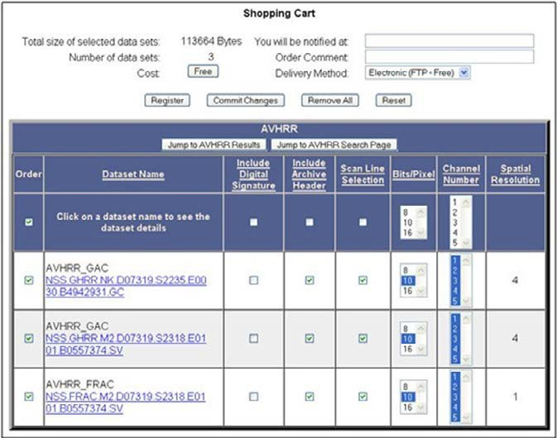
CLASS Shopping Cart—Order Page

International Satellite Cloud Climatology Project (ISCCP)

Ongoing research at NCDC is progressing toward produc- ing a new satellite resource for climate science. Originating from the International Satellite Cloud Climatology Project (ISCCP), the data are observations from all channels on the GOES series, the European Meteorological satellite (Me- teosat) series, the Japanese Geostationary Meteorological Satellite (GMS) series and the Chinese
Fen-yung 2C (FY2) series. The period of record covers
1979 through the present, yet its total size is less than
two terabytes since the data are sampled to 10-km
and 3-hour resolution. Because the original data were
archived in various formats, a consistent format has been
developed for easier access to the datasets. For scientific
researchers who need a high-resolution global gridded da- taset, the new ISCCP B1 product (described below) is likely the one they’ll need. http://www.ncdc.noaa.gov/oa/rsad/ isccpb1/ index.php

Global ISCCP B1 Browse System (GIBBS)

As a by-product of an effort to recreate a streamlined, user
-friendly ISSCP B1 product, NCDC has produced a satellite
browse dataset containing full-earth images beginning
as early as 1974 and updated daily. The GIBBS contains
over one million browse images for every three hours from
all geostationary satellites around the world. Follow the
Satellite Imagery link on the Satellite Data page.

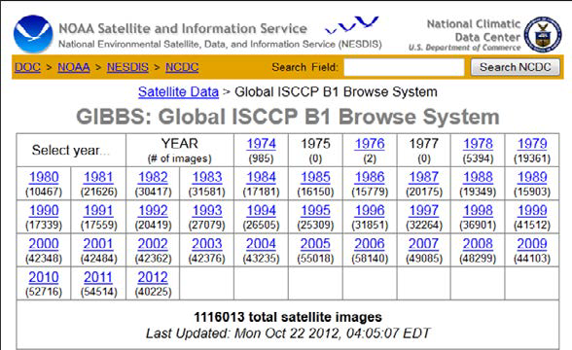
http://www.ncdc.noaa.gov/gibbs/

Hurricane Satellite ISSCP B1 (HURSAT-B1)

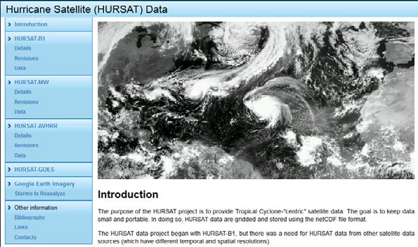
HURSAT-B1 data is derived from International Satellite Cloud Climatology Project (ISCCP) B1 data spanning over 30 years. Version 5 is the newest version of-
fered. It provides coverage of global tropical cyclones at 8-km spatial resolution and 3-hour temporal resolu- tion. Also, visitors can access downloadable images
and view hurricane movies via HURSAT.

http://www.ncdc.noaa.gov/oa/rsad/hursat/

International Best Track Archive for Climate
Stewardship

IBTrACS provides tropical cyclone best track data in a cen-
tralized location to aid our understanding of the distribu-
tion, frequency, and intensity of tropical cyclones world- wide. Data availability was resolved by working directly with all the Regional Specialized Meteorological Centers and other international centers and individuals to create a global best track dataset, merging storm information from multiple centers into one product and archiving the data for public use.

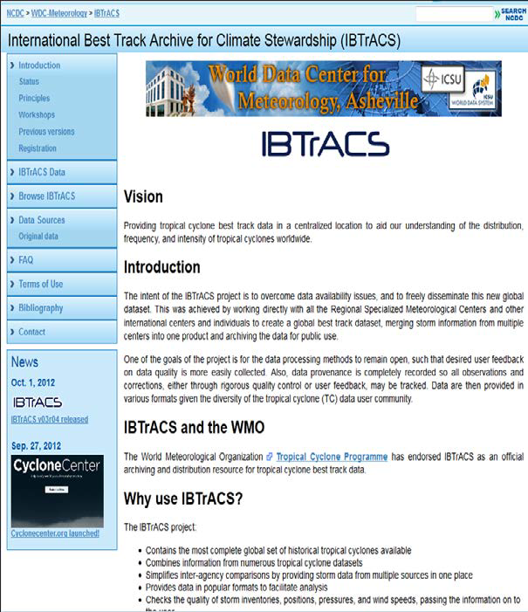

http://www.ncdc.noaa.gov/oa/ibtracs/index.php

Climate Data Records (CDR) Program

The Climate Data Records (CDR) program is part of NOAA’s mandate to provide the nation with objective data and tools to help characterize, understand, predict, mitigate, and adapt to climate change and variability. CDRs are the result of the Scientific Data Stewardship (SDS) Project, an
interagency partnership originated in 2002 to develop and implement a robust, sustainable and scientifically defensi- ble approach to producing and preserving climate records from satellite data. In 2009, the SDS Project was renamed the CDR Program (CDRP). Currently, there are 11 opera- tional products offered from NCDC with more on the way. Please follow the link below for access and documentation to the CDR Program.

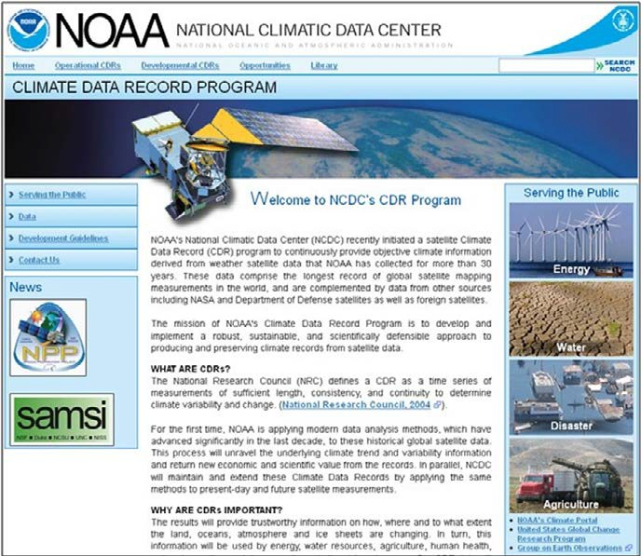

http://www.ncdc.noaa.gov/cdr/index.html

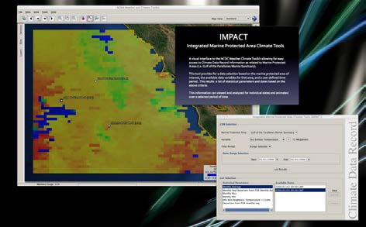
The NSIDC Climate Data Record (CDR)
of sea ice concentration is available
at 25-km spatial resolution in daily or
monthly time steps for 1987-2007 (the
example below is from September
2007). The CDR provides a spatially
and temporally consistent measure of
sea ice suitable for studies of climate
variability and change as well as for ap-
plications useful to the shipping, ener-
gy, and tourism sectors, among others.
The CDR is produced by reprocessing
data from the Special Sensor Micro-
wave Imager (SSMI), a sensor flown
on Department of Defense satellites
since 1987. NSIDC applies two different
methods, dubbed the NASA Team and
Bootstrap algorithms, to determine sea
ice concentration. Quality-control processes are applied
throughout. For more detailed information see http://
climatedataguide.ucar.edu/guidance/noaansidc-climate-
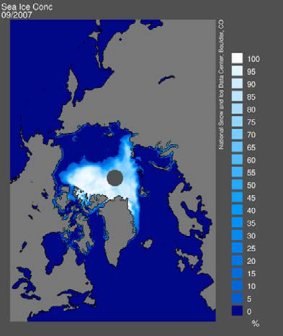
data-record-passive-microwave-sea-ice-concentration.

This CDR is used by (1) climate scientists to deter- mine the accuracy and reliability of computer-gen- erated climate projections, (2) shipping companies
to aid in anticipating and selecting passages through the Arctic, (3) energy development companies as- sessing access to new reserves, (4) meteorologists in support of near-real time weather prediction, and (5) environmental groups concerned with the migration patterns and habitat changes of Arctic wildlife.

To support access, uptake and use of CDRs, the Program led the development of a generic climate data tool kit. The pilot application of the kit is the Integrated Marine Protected Area Climate Tools (IMPACT). Designed to support NOAA’s Gulf of the Farallones National Marine Sanctuary (NMS), IM- PACT provides climate change impact data, informa- tion, and analysis to a wide range of stakeholders in coastal California. The image below shows a projec- tion of the Sea Surface Temperature CDR over the Gulf of the Farallones NMS. IMPACT allows seamless integration and spatial/temporal analysis of satellite and in situ data as well as CDRs and resource man- agement data, including unique user-supplied datas- ets. The IMPACT framework can be readily adapted to suit other areas, sectors, and needs.

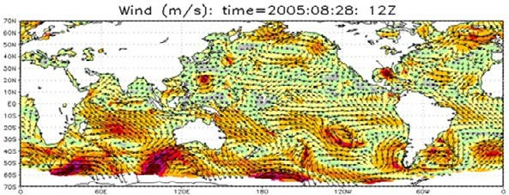
Sea Winds

The Blended Sea Winds product con- tains globally grid- ded, high-resolution ocean surface vec- tor winds and wind stresses on a global
0.25° grid, and in multiple time reso- lutions of 6-hourly, daily, monthly, and a
11-year (1995-2005)
climatological monthly analyses. The period of record is
July 9, 1987 to present. Data are accessible through FTP or
OPeNDAP/THREDDS Data Server. See http://www.ncdc.
noaa.gov/oa/rsad/air-sea/seawinds.html

NOAA Optimum Interpolation
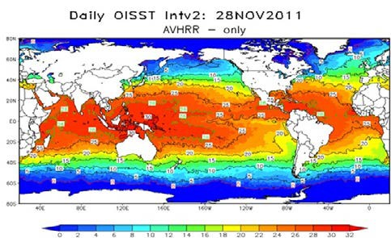
1/4 Degree Daily Sea Surface
Temperature Analysis

The optimum interpolation (OI) sea surface temperature (SST) analysis is produced daily on a 0.25° grid.
The analysis uses in situ and satellite SST’s plus SST’s simulated by sea ice cover. Before the analysis is com- puted, the satellite data is adjusted for biases.

Custom Satellite Images:

NCDC provides custom satellite imagery from NOAA satellites based on user-specified criteria. The images also can be certified for court use. Please contact NCDC for details on ordering and image-enhancement options.

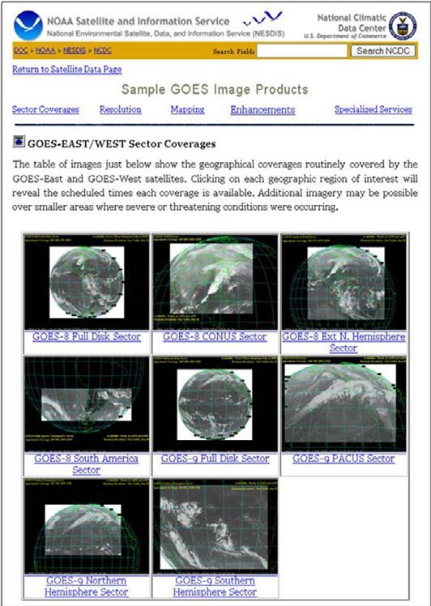
http://www.ncdc.noaa.gov/oa/rsad/netcdf-access/index.php

Service Fees: NCDC recently announced that all of its on- line data is now available for download free of charge. Re- quests and orders for certain products and those shipped on physical media still require pre-payment, however. Our two most popular media are external disk drives and LTO tapes. Also, service fees may apply to very large orders
in access of 100 GB, which must be manually processed and either copied to physical media or placed on FTP server. These types of orders can take several weeks
to be completed and shipped. Before using the contact information below, please read the instructions at http:// www.ncdc.noaa.gov/customer-support to determine if your product needs have a fee associated with them.

Contact information for satellite data and products:

Telephone: 828-271-4850 x3183
Facsimile: 828-271-4876
E-mail: ncdc.satorder@noaa.gov

Model Data, Products & Service

National Climate Model Portal

The National Climate Model Portal (NCMP) is being developed to provide reliable, consistent, long-term public access, interoperability, and intercomparison of climate reanalysis products and observational datasets for all
levels of expertise and will be the initial access point for model data under NOAA’s Climate Services Portal (NCSP). With the development of tools for improvement and use of model data and information underway, an important early NCMP contribution is access to several reanalysis datasets, including the NCEP Climate Forecast System Reanalysis (CFSR) and North American Regional Reanalysis
(NARR). For example, Global CFSR data in the figure below
depict the very impressive arctic air mass in place over North America on Christmas Day, 1983, under which numerous temperature records

were broken and citrus crop damage measured in the billions. The
NCMP website–currently under development and
available at http://ncmp.ncdc.noaa.gov–will direct users to advanced model data services and information.

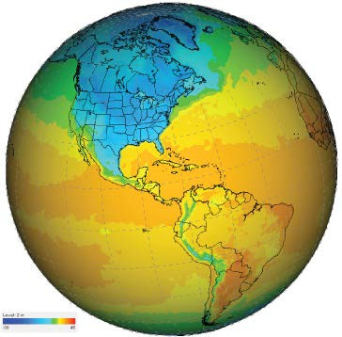

12 UTC 25 December 1983
CFSR 2 m Temperature (ºC)
Generated from NCMP/NOMADS data with Unidata IDV

NOAA National Operational Model Archive and Distribution System (NOMADS)

To address the growing need for real-time and retrospective access to a wide spectrum of model data, NOAA’s National Climatic Data Center (NCDC), National Centers for Environmental Prediction (NCEP) and Geophysical Fluid Dynamics Laboratory (GFDL) initiated NOAA’s National Operational Model Archive and Distribution System (NOMADS). The model dataset archive established by NOMADS includes:
• Numerical Weather Prediction (NWP) models [GFS, NAM, RUC, RAP]
• Multi-member ensembles [GENS]
• Global Data Assimilation System (GDAS) model input and restart files

Methods of access for data and derived products:
• Distributed format independent access via OPeNDAP
• FTP and HTTP access to data subsets in their native format
• Web plotting and aggregation service
• Live Access Server (LAS) and GrADS Data Server (GDS)
• Unidata’s THREDDS Data Server (TDS) services including OpenGIS Web Coverage Service (WCS) and Web Map
Service (WMS)

Additionally, NOMADS provides customer support for users of advanced model data and information. Contact information: phone: (828) 271-4800; email: NOMADS.ncdc@noaa.gov

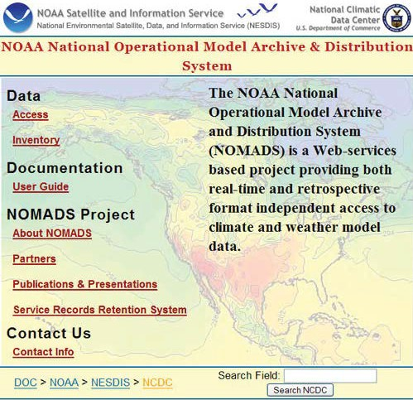

NOMADS Home Page - http://nomads.ncdc.noaa.gov/

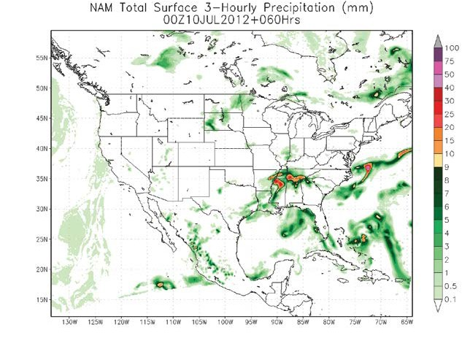
North American Mesoscale (NAM) total surface 3-hourly precipitation

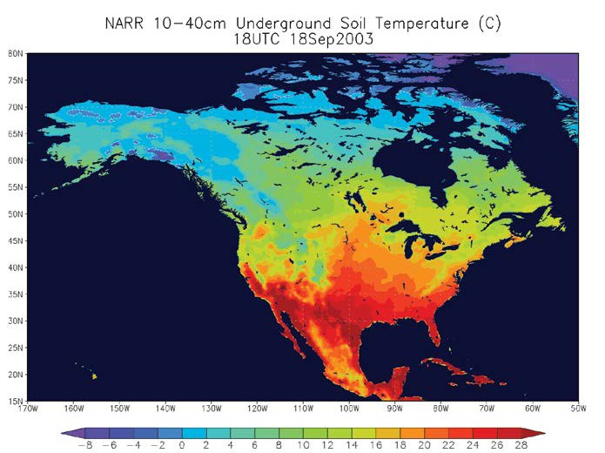

North American Regional Reanalysis (NARR) underground soil temperature
(a layer from 10cm to 40cm below ground)

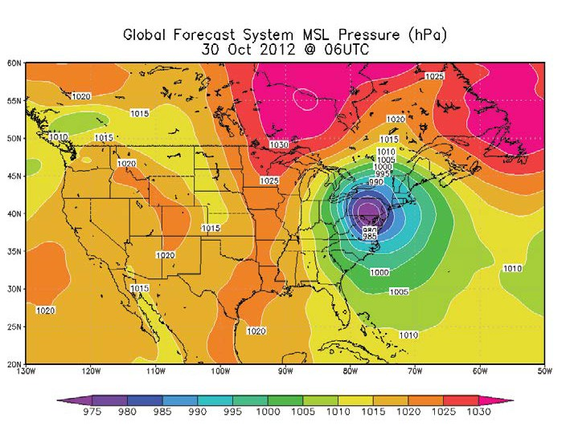

Global Forecast System (GFS) mean sea level pressure showing super-storm 2012

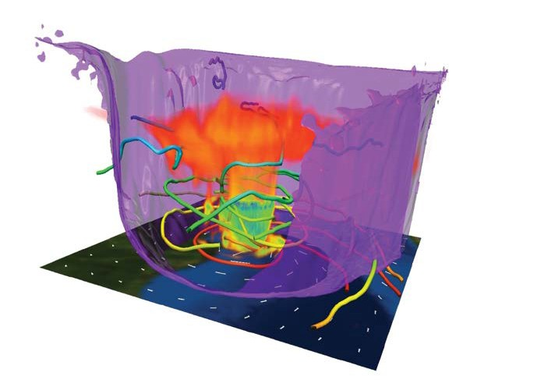
Downscaled Global Forecast System (GFS) model data showing Hurricane Katrina making landfall on August 29, 2005



Paleoclimate Data

DATABASE: Paleoclimate Data—data about past climate and environment derived from a diverse range of proxies such as tree rings and ice cores. The data are time series of geophysical or biological measurements, and some include reconstructed climate variables such as temperature and precipitation.

• Data Type: ASCII character data;
• Quality Control: Undergoes publication peer review and some manual QC
• Data Origin: Academic and Government researchers
• Content/Elements: Time series of geophysical or biological measurements, processed average proxy values
such as tree growth indices, and reconstructed climate variables
• Period of Record: All time periods prior to instrumental weather records, extending from hundreds to millions
of years before present.
• Online—http://www.ncdc.noaa.gov/paleo/paleo.html

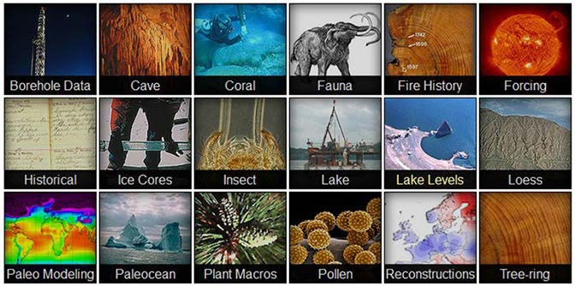

http://www.ncdc.noaa.gov/paleo/paleo.html

NOAA’s Regional
Climate Centers


The National Oceanic and Atmospheric Administration’s (NOAA) Regional Climate Centers (RCCs) are a federal– state cooperative effort. The RCC Program is managed by NOAA’s National Climatic Data Center (NCDC). The RCC Program directly supports the following legislative mandates:

National Climate Program Act of 1978 (15 U.S.C. 2901,
2908 (PL 95-367))—mandate “…to improve the use and
dissemination of climatic data and information for the eco-
nomic benefit and well-being of the United States.”

U.S. Global Change Research Act of 1990 (PL 101-606)— calls for the Federal Government to ”...combine and in- terpret data from various sources to produce information readily usable by policymakers attempting to formulate effective strategies for preventing, mitigating, and adapt- ing to the effects of global change.”

The six centers that comprise the RCC Program are en- gaged in the timely production and delivery of useful cli- mate data, information, and knowledge to decision makers and other users at the local, state, regional, and national levels. The RCCs support NOAA’s efforts to provide op- erational climate services while leveraging improvements
in technology and collaborations with partners to expand quality data dissemination capabilities. The RCCs respond annually to tens of thousands of requests for data and information from citizens, state and federal agencies, and weather-sensitive businesses (agriculture, transportation, risk management, etc.). More than 100 million requests for information are received annually through RCC online data systems. Information tailored to specific regional needs is generated at the RCCs and is shared with NCDC, National Weather Service (NWS) offices, and other agencies to en- sure an integrated approach to climate analyses, planning, and dissemination for the benefit of all climate information users. RCC data delivery to the larger climate community relies on a nimble combination of near-real-time relational databases and Web-based information resources.
The current configuration of RCCs includes six centers located at Cornell University in Ithaca, New York; the University of North Carolina at Chapel Hill; Louisiana State University in Baton Rouge; The University of Nebraska in Lincoln; the Illinois State Water Survey in Champaign; and the Desert Research Institute in Reno, Nevada. The figure on the following page illustrates the location of the six RCCs, representing each geographic region of the United States.

ACIS (http://rcc-acis.org/) is the RCC backbone for dissemi- nating NCDC climate information to partners and a host of regional and state climate data users. In recent years, re- quests for climate information from the RCCs have grown rapidly as products have been developed for many sectors, including risk management, energy production, agricultural planning, transportation services, and the general public.

NOAA’s Regional Climate Services Partnership

Changing climate conditions impact our lives in both subtle and measurable ways. Whether we are facing extreme precipitation events, earlier snowmelt, increased frequency and duration of drought, alterations to the growing season, or rising sea levels, the key to anticipating and responding to these changes is having the right
kinds of climate information at a scale appropriate for community decision-making.

NOAA’s Regional Climate Services Partnership makes climate information relevant and accessible to people
from coast to coast. From engineers to insurers, gardeners to public health officials, people who use climate data, forecasts, products, and services will find that NOAA’s Regional Climate Services Partnership is the one stop shop for their information needs.

This Partnership reflects NOAA’s commitment to healthy ecosystems, communities and economies that are resilient in the face of variable and changing climate conditions.
It seeks to assess regional needs and vulnerabilities, and

then develop and deliver timely climate services that aid mitigation and adaptation choices. The Partnership also works to build a climate-literate public that understands its vulnerabilities so that it can appropriately plan ahead.

Anchorage, AK / Honolulu, HI Kansas City, MO / Fort Worth, TX Bohemia, NY / Salt Lake City, UT

Learn more about the RCSDs at: http://
www.noaaideacenter.org/rcsd/

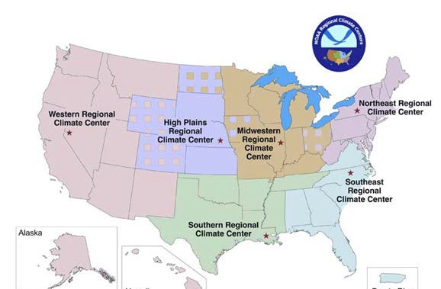

http://www.ncdc.noaa.gov/oa/climate/regionalclimatecenters.html

CD-ROM/DVD Products

NCDC has produced a suite of CD-ROMs and DVDs with diverse environmental data ranging from global tropical cyclone tracks, to worldwide climatologies, to hourly surface data. Below is a listing with descriptions of some of the more popular discs we offer. A more extensive listing, further details concerning these discs, as well as an online ordering system (with discounted prices vs. those listed below), are accessible via:

http://ols.nndc.noaa.gov/plolstore/plsql/olstore.prodlist?
category=C&subcatc=01&groupin=CDV.

Integrated Surface Hourly Observations:
The global surface hourly observations contained on this CD-ROM/DVD set are integrated from all of the NCDC and Navy surface hourly data, NCDC hourly precipitation, and Air Force surface hourly data. Hourly and synoptic type data for approximately 12,000 global stations are available for 1995–2005. There are 24 volumes (1995–2002) separated by geographic region and time period. Global extraction software, including a map interface, is provided to aid in identifying and easily selecting the data in
either full Integrated Surface Hourly format or delimited/ abbreviated format. Various elements such as temperature, dew point, wind speed and direction, sea level pressure, visibility, cloud ceiling, present weather, precipitation, snowfall, snow depth, altimeter setting, station pressure, etc., are available. The disks also contain a data inventory file showing the number of observations for each month
of the year for each station. Each volume contains all the software, support files, and documentation so that each volume may be used alone or in combination with other volumes for each time period. An additional nine volumes (no extraction software included) on DVD cover 2003–2011 with each year available on a single DVD. $35 per volume.

International Station Meteorological Climate Summary
(ISMCS) Ver. 4.0:
This product provides detailed climatological summaries for 2,600 locations worldwide. These locations include National Weather Service stations, domestic and overseas Navy and Air Force sites, and numerous foreign stations. Limited summaries also are given for approximately 4,000
additional worldwide sites. This version also contains year/ month information and long-term mean precipitation data for 1,000 foreign locations. Tabular or statistical data can be printed or exported to a spreadsheet. This dataset is a joint NCDC, USAF, and U.S. Navy product. Please note that the non-U.S. data cannot be redistributed for commercial purposes by users of the CD. $35.

NCDC Cooperative Station Data:
These CD-ROMs contain ASCII data files and associated station history files for the Cooperative Summary of
the Day dataset. This dataset is a compilation of daily observations from more than 20,000 cooperative weather stations in the United States, U.S. Caribbean Islands, U.S. Pacific Islands, and Puerto Rico. It includes air and soil temperatures, rainfall, snowfall, and evaporation elements. A map interface is available on the Eastern, Central, and Western Disks. The period of record on these disks varies among stations but falls within the period from the 1850s through 2001. The update disk contains compressed files for 2002–2006 and also includes data for the “first-order ” National Weather Service sites, with some additional data elements that are not reported by cooperative stations.
The files are in the raw, archive format without any software for conversion to a spreadsheet-ready format.
$105 for full set/$35 per volume/update disk.

Engineering Weather Data:
This CD-ROM contains an update of a very popular publication that was first printed by the Air Force in 1967 and republished in 1978. As compared to the original Engineering Weather Data publication, the new interactive CD-ROM database contains updated meteorological
tables, new, summarized parameters, and graphical displays. Approximately 800 worldwide stations have been summarized. For each station, the data and information
on this CD-ROM include: summarized design criteria data for dry and wet bulb temperatures and humidity ratios, average annual climate summaries, psychrometric summaries, binned temperature data, annual temperature and humidity summaries, heating and cooling degree data summaries for building envelop loads, ventilation and infiltration loads, solar radiation data, and seasonal wind direction and wind speed summaries. Please note that

the non-U.S. data cannot be redistributed for commercial purposes by users of the CD. $35.

Important Notes:

Some NCDC CD-ROM products were produced for use in a
‘DOS’ or Windows PC environment and will not work in an
Apple ‘MAC ’ environment. In addition, some of the NCDC
CD-ROMs were produced in a pre-Windows 95/98/XP/7
environment and may not work without configuration. If
you have technical questions, email ncdc.orders@noaa.gov.

NCDC’s User Engagement Service’s Branch is responsible for distribution of NCDC CD-ROM/DVD products.

Ordering information—by mail, by phone, by email, or via
NCDC’s Online Store:
Attn: User Engagement
Services Branch
National Climatic Data Center
151 Patton Ave, Asheville
NC 28801-5001
Telephone: 828-271-4800
Fax: 828-271-4876
Internet: ncdc.orders@noaa.gov

Online Store: http://ols.nndc.noaa.gov/plolstore/plsql/
olstore.main?look=1

Prepayment must accompany orders. We accept payment by Visa, MasterCard, American Express, Discover, wire transfers, and Automated Clearing House. For domestic orders, please add $3.00 service charge per order; foreign orders, add $39.00 per order.

Publications

A number of NCDC Climatic Summaries, Publications, and
Documents are available online.

Climatic Summaries, Publications & Documents

• Annual Climatological Summaries (Monthly/Annual
Summaries for U.S. Locations)
• Climatological Data (Daily/Monthly Data for ~ 8,000
U.S. Locations)
• Climate Variations Bulletin (Monthly Reports of U.S.
Climate)
• Climatic Data for Frost-Protected Shallow Founda-
tions
• Climate Maps for the United States (Over 700 Maps
of Climate Normals)
• Comparative Climatic Data (Climatological Averages
for U.S. Cities)
• Climates of the World (PDF format, Regional Narra-
tives and Climatic Tables by City)
• Climatography of the U.S. - Supp #3 (Maps of Tem-
perature, Precip, Degree Days)
• Climatology for Southwest Asia (Many Data Sources
and Summaries)
• COOP Data/Record Of Climatological Observations
Form
• Dynamic Normals (19 products—e.g., Daily Cooling
Degree Days)
• Freeze/Frost Data for the U.S. (PDF format)
• Frost Free Maps for the U.S. (Based on 28°F and
32°F Temperatures)
• Heating and Cooling Degree Days (Monthly State,
Regional, and National Degree Days)
• Historical Climate Publications (Publications and
CD-ROMs—for sale at a very reduced price)
• Hourly Precipitation Data (Hourly Precip Data for
over 2,500 U.S. Locations)
• Hourly Rainfall Event Statistics (Frequency Distribu-
tions for Hourly Rainfall)
• Integrated Surface Hourly (ISH) Summaries (Sum-
maries of Temperature, Wind, Ceiling/Visibility, etc.
Note: Choose Advanced Options at Accessing data
selection screen, then Data Summary as output on
following screen.)
• Local Climatological Data (Hourly/Daily Data for
nearly 300 U.S. Cities)
• Monthly Climatic Data for the World (Selected
Worldwide Cities’ Climate Summaries)
• Monthly Extremes (30 products—e.g., Maximum
Precipitation by Month )
• Monthly Weather Review (American Meteorological
Society Summary)
• Rainfall Frequency Atlas of the U.S. (Frequency Dis-
tributions for Heavy Rainfall)
• Storm Data Publication (Monthly Reports of Damag-
ing Weather)
• U.S. Climate Normals (The New U.S. Climatological
Normals)

http://www.ncdc.noaa.gov/oa/climate/climateprod ucts.html#PUBS

Historical and offline publication requests should be directed to NCDC Customer Service at the following contact information:
Phone: 828-271-4800
Fax: 828-271-4876
E-Mail: NCDC.Orders@noaa.gov

Climate Monitoring

One very important role of NOAA’s National Climatic Data Center (NCDC) is to monitor and assess the state of the Earth’s climate in near real-time, providing data and information on climate trends and variability—including perspectives on how the climate of today compares to the past—to decision-makers at all levels of the public and pri- vate sector. In that role, NCDC’s Climate Monitoring Branch at routinely produces climate assessments on a monthly, seasonal, and annual basis. The purpose of these reports, which are available back to 1998, is to provide scientific insight into the Earth’s climate and historical perspective
on its variability and change.
The Climate Analysis reports, which place the conditions for the past month, season, and year-to-date period into historical perspective, are provided as data become avail- able. Parts of the report are available online as early as the
5th of each month, and the full report is released on the
15th (or next business day). Each report includes hundreds of graphics and text summaries of global and U.S. climate conditions with historical perspective provided by more than 100 years of instrumental observations and hundreds of years of paleoclimate data from sources such as tree rings, ice cores, and sedimentary records. The reports consist of several sections summarizing conditions on both a U.S. and global scale.

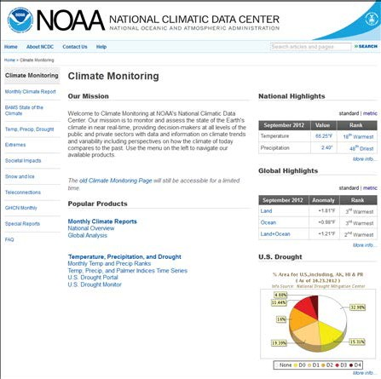
The section on global conditions in- cludes data on surface and upper air temperatures, precipitation, ENSO conditions, sea ice, and snow cover.

A U.S. National section provides statewide, regional, and national rankings for mean temperature and precipitation. User-friendly graphics and short explanatory discussions make determination of conditions quick and easy.

What follows are more prominent analyses sought after by NCDC customers.

http://www.ncdc.noaa.gov/climate-monitoring/index.php

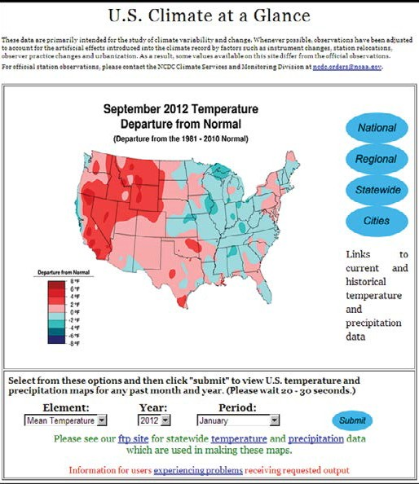

U.S. Climate at a Glance

The U.S. Climate at a Glance
web page is a popular and easy- to-use source of climate infor- mation on national, regional, statewide, and city temperature and precipitation trends and rankings. Here, users can view a number of different statistics in addition to a bar or line graph: temperature or precipitation values for any month or sea-
son from 1895 to present; the respective ranking for each year from warmest to coldest or dri- est to wettest; the climatological average for any selected base period; and the linear trend over the period selected. Mapping of statewide temperature and pre- cipitation values for any month or season during the period of record is also possible.

http://www.ncdc.noaa.gov/oa/climate/research/cag3/cag3.html

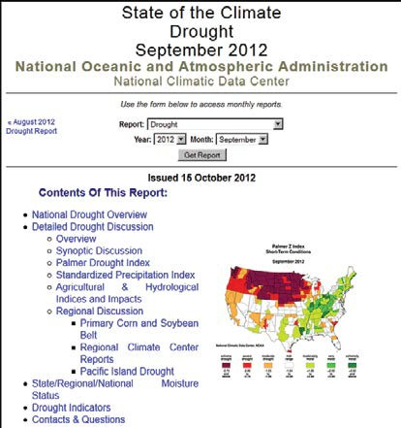

http://www.ncdc.noaa.gov/sotc/?report=drought

The U.S. Drought section provides numerous drought indicators and sum- maries of national, regional, and local drought conditions during the past month with perspective on how the conditions compare with those during the preceding centuries.

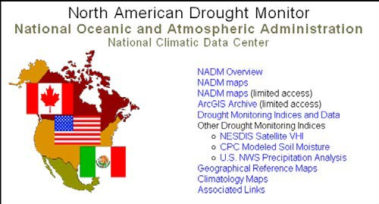
The North America Drought Monitor (NADM) is a co- operative effort between drought experts in Canada, Mexico and the United States to monitor drought across
the continent on an ongoing
basis.

http://www.ncdc.noaa.gov/temp-and-precip/drought/nadm/

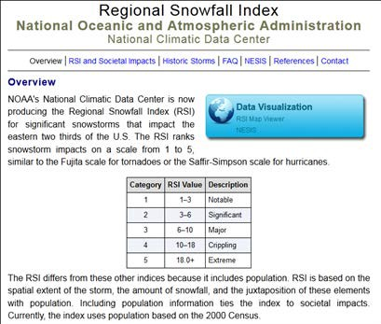
NCDC produces the Regional Snowfall Index (RSI) for significant snowstorms that impact the eastern two thirds
of the United States. The RSI ranks snowstorm impacts on a scale from
1 to 5, similar to the Fujita scale for tornadoes or the Saffir-Simpson scale for hurricanes.

http://www.ncdc.noaa.gov/snow-and-ice/rsi/

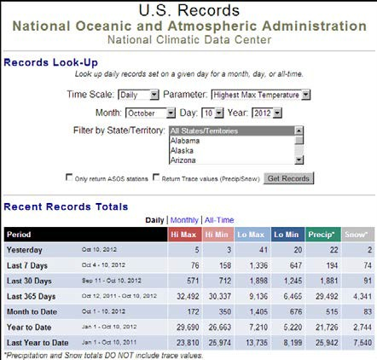
The U.S. Records page provides an easy and quick way to search for tem- perature, precipitation and snowfall station records set on a given day or month.

http://www.ncdc.noaa.gov/extremes/records/

The Global Hazards/Climate Extremes page was first presented in 2003 as a framework to summarize weather- related hazards and disasters around the world in recent months. The page is updated on a weekly basis and is focused on the following events: drought, excessive heat,
flooding, severe storms, tropical cyclones, extratropical cyclones, and severe winter weather. The information provided is a compilation from media news with satellite images and/or graphs that are relevant to the story.

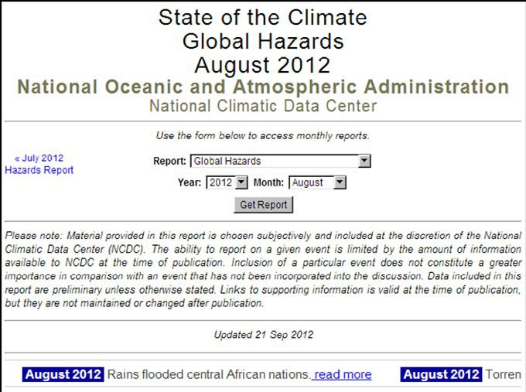
http://www.ncdc.noaa.gov/sotc/hazards/

NCDC is the Nation’s scorekeeper in terms of addressing severe weather/climate events in their historical perspec- tive. As part of its responsibility of monitoring and as- sessing the climate, NCDC tracks and evaluates climate events in the U.S. and globally that have great economic and societal impacts. NCDC is frequently called upon to
provide summaries of global and U.S. temperature and precipitation trends, extremes, and comparisons in their historical perspective. Found here are the weather/climate events that have had the greatest economic impact from
1980 to 2011. Updates will coincide with the annual State of the Climate published in the Bulletin of the American Meteorological Society.

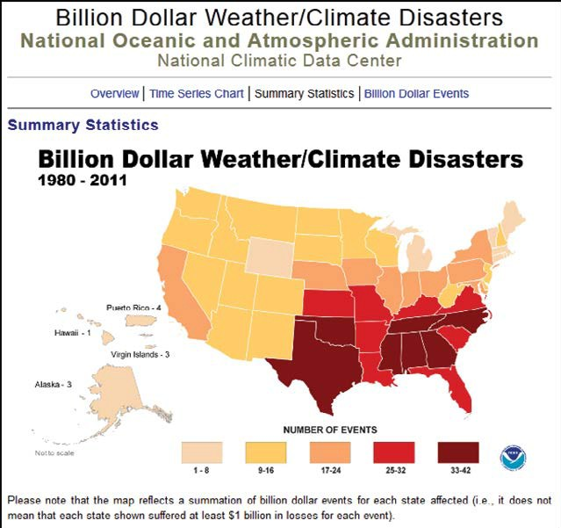

http://www.ncdc.noaa.gov/billions/

NCDC Sectoral and
Regional Engagement




As part of its desire to reach out to climate-sensitive users, NCDC has expanded its services to include sectoral- and regional-specific resources. The Sectoral & Regional http://www.ncdc.noaa.gov/sectoral-regional web page introduces information of interest to various sectors and entities. The web page also houses the Residential Energy Demand Temperature Index (REDTI), a valuable tool for explaining year-to-year fluctuations in energy demand for residential heating and cooling. In addition, the description of and links to the activities, climate information and work- shops in the Pacific Region are provided. Updates planned include details from the other five regions and engage- ment workshops hosted or co-hosted by NCDC.

User Engagement Fact Sheets by Sector Downloadable information sheets suitable for further distribution provide an overview of the sector, key stake-
holders, examples of sector needs, and NCDC data and products relevant to the sector.

Agriculture
Forests and Forest Ecosystems
Civil Infrastructure
Construction
Coastal Hazards
Energy
Health
Insurance
Litigation
Marine and Coastal Ecosystems
National Security
Tourism
Transportation
Water Resources

NCDC Customer
Service Contacts


NCDC provides a wide range of services to various users, ranging from large engineering firms designing the latest in safe, energy efficient structures, to the attorney docu- menting a weather event, to the individual planning
a retirement move.

Services offered include data resource consultations, sub- scription items and publications, copies of original records, certifications, generation of specialized climate studies,
and a host of other climate-related activities. Services are delivered on a variety of media, including online access, CD-ROM’s, DVDs, computer tabulations, maps, and publications.

Customer Support

For specific information regarding NCDC products and ser- vices, customer support is only an email, fax, or call away. The customer support center is open Monday through Friday from 8:00 a.m. to 6:00 p.m. Eastern Time except Federal Holidays.

For Weather and Climate Data and Products:
Phone: 1-828-271-4800 then press “2”
Fax: 1-828-271-4876
TTY: 1-828-271-4010
Email: ncdc.orders@noaa.gov

For Satellite Data and Products: Phone: 1-828-271-4850 then press “1” Fax: 1-828-271-4876
TTY: 1-828-271-4010
Email: ncdc.satorders@noaa.gov
NCDC’s Tax ID is #520821608. Data Issues
If you have issues to report regarding the quality of NOAA
data and you are a NOAA employee, you may file a report
here. Non-NOAA employees can send an email to ncdc.orders@noaa.gov.

Website Issues
Web page functionality problems (includes broken links
and/or missing images). Users must be aware that the
spam filters block messages with no subject line and sub-
ject lines that appear to be spam. Be sure to include the
address of the page that you are contacting us about.
Email: ncdc.webmaster@noaa.gov

Media Contact
If you are a member of the media interested in talking to
an NCDC staff member, please contact:

Katy Vincent
Email: katy.vincent@noaa.gov



