Climate Data Record (CDR) Program
Template for
Operational Algorithm Description (OAD)


CDR Program Document Number: CDRP-TMP-0043
Configuration Item Number: N/A
Revision 2 / March 13, 2014

PURPOSE OF THIS TEMPLATE
This template is used by the NOAA Climate Data Record (CDR) Program as the basis for creating a standardized Operational Algorithm Description Document (OAD) for each CDR during its transition to Full Operating Capability (FOC).
See the document “Instructions for Using CDR Program Templates” [CDRP-INST-0410] for details on how to fill out this template.
TEMPLATE REVISION HISTORY
Rev. | Author | DSR No. | Description | Date
1 | Brian Newport and Bernardo Torres, Global Science and Technology, Inc. | DSR-051 | Initial Release. | 4/25/2013
2 | Brian Newport, Global Science and Technology, Inc. | 621 | Moved instructions to a separate document “Instructions for Using CDR Program Templates” [CDRP-INST-0410]. Simplified version identification table. Implemented standardized CDR names. Reformatted using CDRP Master Template Rev 2. | 3/13/2014

Delete this page and the preceding cover page prior to submission, including the section break that appears immediately after this text.
Climate Data Record (CDR) Program

Operational Algorithm Description Document (OAD)

<CDR Web Page Name from CDRP-STD-0261>

CDR Program Document Number: CDRP-XXX-XXXX by CDRP Document Manager
Configuration Item Number: TBD from current version of CDRP-STD-0261
Revision 1 / DRAFT <Month> <day>, YYYY
REVISION HISTORY
Rev. | Author | DSR No. | Description | Date
1 | Name, Org | DSR-XXX | Initial Submission to CDR Program | MM/DD/YYYY

TABLE of CONTENTS
Update this table by right click (Windows) or Control-click (Mac OS-X) and selecting the “Update Field” option from the context menu.
1. Introduction 8
1.1 Purpose 8
1.2 Product Description 8
1.3 Version Identification 8
1.4 Applicable Documents 9
1.5 Reference Documents 9
1.6 Document Organization 10
1.7 Document Maintenance 10
2. System Context 11
3. Operational Scenarios 12
3.1 Create a Reprocessed Climate Data Record 12
3.2 Create an Interim Climate Data Record 12
3.3 Create Preliminary Climate Data Products 12
4. Logical View 13
4.1 Executable Components and Connectors 13
4.2 Module Decomposition 14
4.3 Third Party Software Components 15
4.4 Uses Dependencies 16
4.5 Layered View 18
4.6 Generalization 20
4.7 Aspects 20
4.7.1 Quality Flags 20
4.7.2 Numerical Computation 20
4.7.3 Performance Optimization 21
4.7.4 Parallelization 21
4.7.5 Exception Handling 21
5. Process View 22
5.1 Invocation 22
5.1.1 Command Line(s) 22
5.1.2 Control Files 22
5.2 Input Data 24
5.2.1 Remote Sensed Inputs 24
5.2.2 In-situ Measurement Inputs 24
5.2.3 Ancillary Inputs 25
5.2.4 Lookup Table Generation 26
5.3 Input Validation 26
5.4 Intermediate Outputs 26
5.4.1 Level 2 HDF Intermediate Output 26
5.5 Final Outputs 27
5.5.1 Output Files Containing CDR Variables 27
5.5.2 Collateral Output Files 27
5.5.3 Output Files for Operational Monitoring 28
5.6 CDR Data Processing 28
5.6.1 CDR Reprocessing 28
5.6.2 CDR Forward Processing 29
5.6.3 Processing For Preliminary Data Products 29
6. Development View 30
6.1 Code Layout 30
6.2 Data Model 30
6.3 Build Instructions 31
7. Physical View 32
7.1 CPU Resource Needs and Limitations 32
7.2 Operating System 32
7.3 Deployment 33
7.4 Data Staging Area 33
7.4.1 Staging Area Storage Needs 33
7.4.2 Staging Area Layout 34
7.5 Install View 35
7.6 Installation Procedure 35
8. Test Datasets and Tools 37
8.1 Test Input Datasets 37
8.2 Expected Output Datasets 37
8.3 Test Output Analysis 37
9. Data Dictionary 38
9.1 Input Variables 38
9.1.1 Sensor or Measurement Inputs 38
9.1.2 Ancillary Inputs 38
9.2 Intermediate Output Variables 39
9.3 Final Output Variables 39
9.3.1 Geolocation, Orientation, and Time Output Variables 39
9.3.2 CDR Output Variables 40
9.3.3 Collateral Output Variables 40
Appendix A. Acronyms and Abbreviations 41
Appendix B. Glossary 42
Appendix C. Optional 43

LIST of FIGURES
Search Word online help for “Add or delete captions” for assistance with this table.
Figure 1: Context diagram example using a simple data flow diagram. 11
Figure 2: Quasi-UML component and connector diagram for the clavrx software, which includes the components clavrxorb and comp_asc_des_level2b. 13
Figure 3: Example decomposition diagram from Clements et al. (2011), Figure 2.1. 14
Figure 4: Example Uses diagram from Clements et al. (2011), Figure 2.8. 16
Figure 5: Example of a Dependency Structure Matrix from Clements et al. (2011), Figure 2.9. 17
Figure 6: Example layered view from Clements et al. (2011), Figure 2.20. 18
Figure 7: Example Layered view from Clements et al. (2011), Figure 2.26. 19
Figure 8: Example Generalization diagram from Clements et al. (2011), Figure 2.12. 20
Figure 9: Example Logical Data Model from Clements et al. (2011), Figure 2.39 30
Figure 10: Example Logical Data Model depicting internal data structures using a UML class diagram, from Clements et al. (2011), Figure A.7. 31
Figure 11: Example deployment view from Clements et al. (2011), Figure 5.3. 33
Figure 12: Example Install view from Clements et al. (2011), Figure 5.5, showing unpacking of the installation packages DukesBankApp.ear and app-client.jar into individual components installed on the production file system. Most CDRs will be simpler than this. 35
LIST of TABLES
Table 1: Third Party Software Components 15
Table 2: Control file for clavrxorb 22
Table 3: Remote Sensed Infrared Radiance Input 24
Table 4: Near Real Time Ship and Buoy Sea Surface Temperatures 24
Table 5: AVHRR Instrument and Algorithm Constant Files 25
Table 6: Level 2 HDF Intermediate Output from clavrxorb 26
Table 7: Global Grid Output File 27
Table 8: <TBD> Collateral Output File 27
Table 9: Output Files for Operational Monitoring 28
Table 10: Computing Resource Needs 32
Table 11: Data Storage Needed per Month of Record (Gigabytes) 34
Table 12: Measurement Input Data Dictionary 38
Table 13: Ancillary Input Data Dictionary 38
Table 14: Intermediate Output Variables 39
Table 15: Geolocation, Orientation, and Time Output Variables 39
Table 16: CDR output variables appearing in the Level_2b output file 40
Table 17: Collateral output variables appearing in the Level_2b output file 40

- Introduction
  - Purpose
This document describes the operational algorithm used to create the NOAA <CDR Web Page Name from CDRP-STD-0261> Climate Data Record (CDR) from a systems and software engineering perspective. In particular, this document:
- Describes the “as-built” software architecture from multiple views.
- Identifies in detail the measurement and ancillary data inputs needed to produce the CDR.
- Specifies the operational environment needed to produce the CDR.
- Provides a technical basis for the Operator’s Manual or Standard Operating Procedure (SOP).
- Provides a partial technical basis for the <CDR Web Page Name from CDRP-STD-0261> Fact Sheet.
- Provides information for long-term maintenance that cannot be quickly determined by reading the code.
This document does not discuss the sensors, platforms, or theoretical basis of the algorithm. Those aspects are documented in the Climate Algorithm Technical Basis Document for <CDR Web Site Name from CDRP-STD-0261> (CDRP-ATBD-XXXX).
  - Product Description
[REQUIRED] Provide a one-paragraph description of the product(s) produced with this algorithm, using the example below as a guide. There is no need to distinguish between different instances of the product, e.g., products provided with differing latencies.
The OISST product is a high-resolution sea surface temperature (SST) analysis product developed using optimum interpolation (OI). The analyses have a spatial grid resolution of 0.25° and temporal resolution of 1 day. The product uses Advanced Very High Resolution Radiometer (AVHRR) infrared satellite SST data, and also uses sea-ice data to help define the SSTs near the sea-ice margin. It also uses in situ data from ships and buoys and includes a large-scale adjustment of satellite biases with respect to the in situ data.
  - Version Identification
This document describes the version of the software identified in the table below. Other versions of the software may have deviations from this description.
[REQUIRED] Fill out the following table.
CDR Configuration Item No. | <CI Number from CDRP-STD-0261>
CDR Taxonomy Name | <CDR Taxonomy Name from CDRP-STD-0261>
CDR Web Page Name | <CDR Web Page Name from CDRP-STD-0261>
PI Name | <PI Name from CDRP-STD-0261>
Version Number | <Version number from PI (IOC) or NCDC/RSAD/OPS Branch (FOC)>
NCDC Version Control Location | <TBD by NCDC/RSAD Operations Branch>
NCDC Version Control Tag | <TBD by NCDC/RSAD Operations Branch>

  - Applicable Documents
The following CDR Program documents are applicable to the development and preparation of this document.
Document Title | Reference in this Document
CDR Program Document Management Plan | CDRP-PLAN-0004
CDR Maturity Matrix | CDRP-MTX-0008
CDR Maturity Evaluation Guidelines | CDRP-GUID-0020
CDR Program Glossary, Rev.2 | CDRP-MISC-0045

  - Reference Documents
The following documents have been used as reference material for the development and preparation of this document.
Document Title | Reference in this Document
Climate Algorithm Technical Basis Document (C-ATBD) for <TBD Standard CDR Name from CDRP-LIST-261> | CDRP-ATBD-XXXX
Optimum Interpolation Sea Surface Temperature Standard Operating Procedure, Version 1.0 (December 27, 2012) | OISST SOP 2012
NOAA/NESDIS Satellite Products and Services Review Board, System Maintenance Manual Template, Version 2.2 (January 2012). Available at http://projects.osd.noaa.gov/spsrb/doc/System_Maintenance_Manual_Template_2.3.docx. | SPRSB 2012
Clements, Paul, et al., “Documenting Software Architectures: Views and Beyond”, Second Edition, Addison Wesley (2011) | Clements et al. 2011
Krutchen, Philippe, “Architectural Blueprints—The “4+1” View Model of Software Architecture”, IEEE Software 12 (6), November 1995, pp 42-50. | Krutchen 1995
“View model”, http://en.wikipedia.org/wiki/View_model, retrieved March 8, 2013. | Wikipedia 2013
NASA Software Engineering Requirements (NPR 7150.2A). Available at http://nodis3.gsfc.nasa.gov/. | NPR 7150.2A
Robel, Jeffrey (Ed), NOAA KLM Guide with NOAA-N, N’ Supplement, NOAA/NCDC/RSAD (2007) | NOAA KLM Guide
Bach, Maurice J., “The Design of the UNIX Operating System”, Prentice Hall (1986). | Bach 1986

  - Document Organization
Much of this document is organized according to the “4+1” View Model of Software Architecture (Krutchen 1995, Wikipedia 2013). The selection of architectural views is based on a subset of the example in Section 9.3 of Clements et al. (2011). The allocation of specific views to the “4+1” model is discussed in Appendix E.2.1 of Clements et al. (2011).
  - Document Maintenance
This document should be reviewed for accuracy prior to releasing a new version of the software to Production. Any changes should be made according to the process defined by the CDR Program Document Management Plan (CDRP-PLAN-0004).
- System Context
[REQUIRED] One or two sentences describing what the algorithm does, with a reference to the C-ATBD and the most applicable published paper that describes the algorithm.
<Enter text here>
[REQUIRED] A graphic that shows a high level view of the input data sources, processing system, and the data output. A simple data flow diagram may work well here.
Figure 1: Context diagram example using a simple data flow diagram.
- Operational Scenarios
This section identifies the operational scenarios (use cases) for which this software will be used. In order to minimize the cost of maintenance and maximize repeatability of results, it is assumed that the same version of the software will be used in all scenarios, and that in order to meet the varying latency requirements of different user groups the software has the capability for substitution of each input data stream with an alternate lower latency stream that may have a different format.
  - Create a Reprocessed Climate Data Record
A complete reprocessing of the period of record is required in order to establish the consistency of a Climate Data Record during its transition to Full Operational Capability (FOC). In order to be assured of creating a consistent dataset it is necessary to have consistent software, processing environment, input data stream(s), calibration, and ancillary data during a reprocessing.
In order to maintain consistency it will occasionally be necessary to perform a new reprocessing, for example as a result of improvements to the algorithm, input data, ancillary data, or calibration.
  - Create an Interim Climate Data Record
An Interim Climate Data Record (ICDR) is a dataset that has been forward processed, using the baselined CDR algorithm and processing environment, and whose consistency and continuity have not been verified (CDRP-MISC-0045). It is possible that a given CDR algorithm will be used to create several ICDRs in order to satisfy differing latency requirements. Eventually it will be necessary to perform a new reprocessing, and the new reprocessed data record will replace the combination of the CDR and the ICDR(s).
  - Create Preliminary Climate Data Products
OPTIONAL. Use this section to describe any other uses of this algorithm at NCDC or elsewhere. For example, there may be a very low latency product that is not only retained for a few days before being replaced by a more robust product, and is not archived. The word “preliminary” in the section heading may be changed to reflect the names of such products. If the code is used elsewhere, identify whether the code has been branched (“forked”), and if so, which organization performed the branch, the branch date, and the code version immediately before the branch. Also discuss whether the changes on one branch have been merged into the other branch.
<Enter text here>
- Logical View
The logical view primarily supports the functional requirements, i.e., what services are provided to enable the user to accomplish his/her goals. The software is decomposed into a set of key abstractions, taken (mostly) from the problem domain, in the form of data structures, aggregations of code, and interfaces performing specific functions. This decomposition is not only for the sake of functional analysis, but also serves to identify common mechanisms and design elements across the various parts of the software (based on Krutchen 1995).
  - Executable Components and Connectors
[REQUIRED] Provide a Components and Connectors diagram similar to this example for the clavrx software used to create the PATMOS-x data products, including the AVHRR_CH1-2-3a_Reflectance FCDR (Figure 2). For more information on the Components and Connectors view see Clements et al. (2011).
Figure 2 below shows the executable components (including scripts) and their run-time connections.
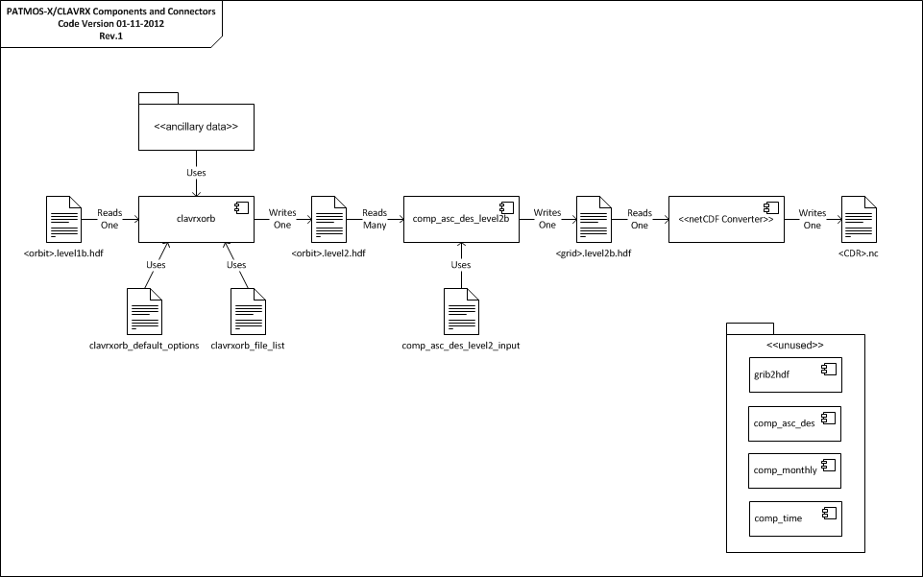
Figure 2: Quasi-UML component and connector diagram for the clavrx software, which includes the components clavrxorb and comp_asc_des_level2b.
Elements of Figure 2 include:
- The clavrxorb component, which processes Level 1b files to produce Level 2 pixel files, one output file per satellite per orbit.
- The comp_asc_desc_level2 component, which transforms a set of Level 2 pixel files to Level 2b global grid files, one output file per satellite per day.
- The NetCDF converter, which converts the HDF Level 2 global grid file to NetCDF format.
  - Module Decomposition
[REQUIRED] A decomposition diagram shows the structure of modules and sub-modules. In particular, this section should identify all of the physical models being used by the algorithm. All of the following text and the figure should be modified, adapted, and extended to best represent the specific algorithm.
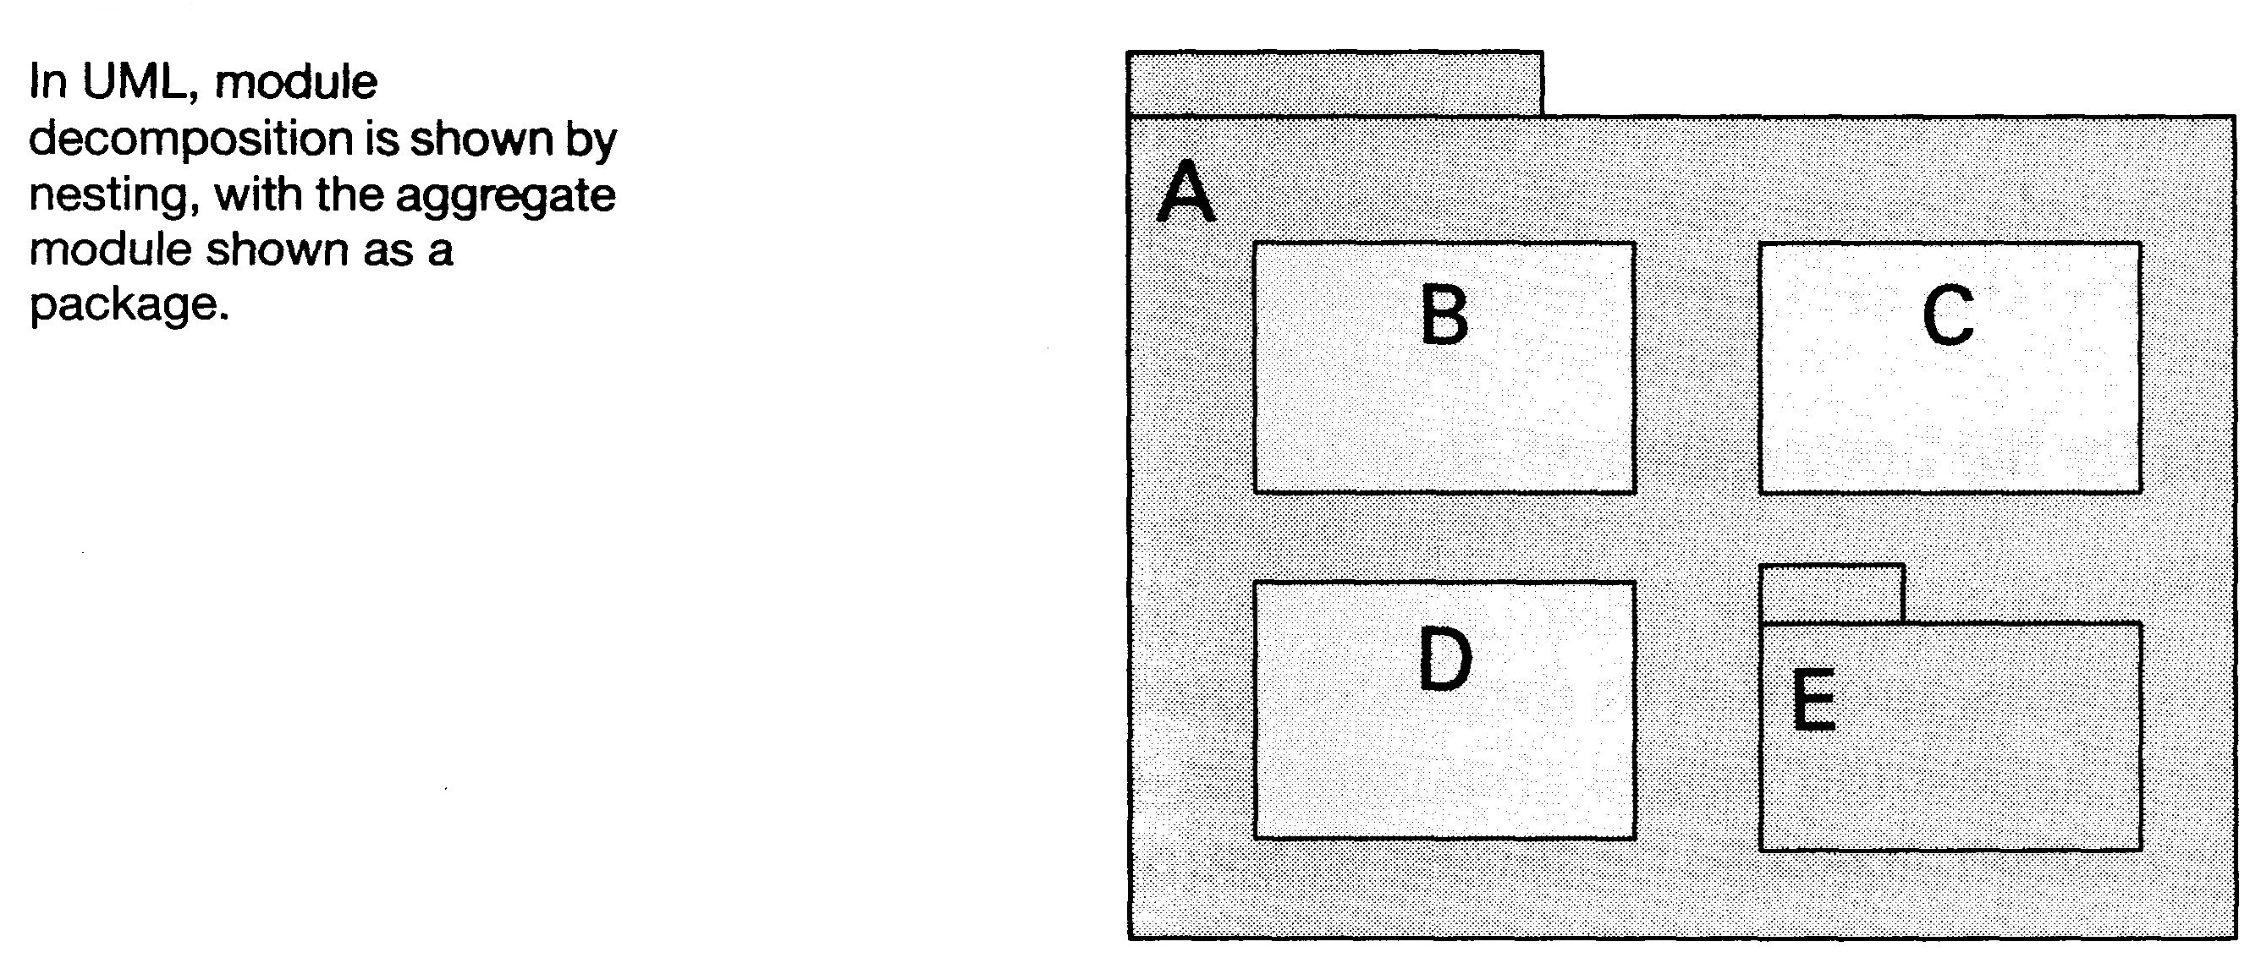
Figure 3: Example decomposition diagram from Clements et al. (2011), Figure 2.1.
As shown in Figure 3, the example algorithm Package A is composed of the following:
- Module B, which reads and validates the input data, and can handle a variety of formats.
- Module C, which is an implementation of Version 3 of the XYZ model (reference).
- Module D, which processes the data one pixel at a time.
- Library Package E, which writes the output data in netCDF format.
- “Glue” code, which provides the connectors among the components.
  - Third Party Software Components
[REQUIRED] Identify all third party software components (including libraries) following the example in the table below.
Table 1: Third Party Software Components
Name | Type | Version | Vendor | License
HDF | Static library | 4.2.7 | The HDF Group | BSD-style
NetCDF | Static library | 4.2.1.1 | Unidata | Lesser GNU Public License

<Enter Text Here discussing the above table>
  - Uses Dependencies
[OPTIONAL] The uses diagram shows dependencies among modules. Module A uses Module B if A depends on a correctly functioning B to satisfy its own requirements. This view may be useful for showing relationships among modules, particularly for planning incremental development, debugging and testing, and gauging the effects of specific changes. It is especially useful for representing utility modules that could be extracted into or replaced by a standard library, such as time and date functions. For CDR code analyzed by the Understand tool (see http://scitools.com/) or other reverse engineering tools, this diagram may be a higher-level abstraction of the dependency information provided by tool.
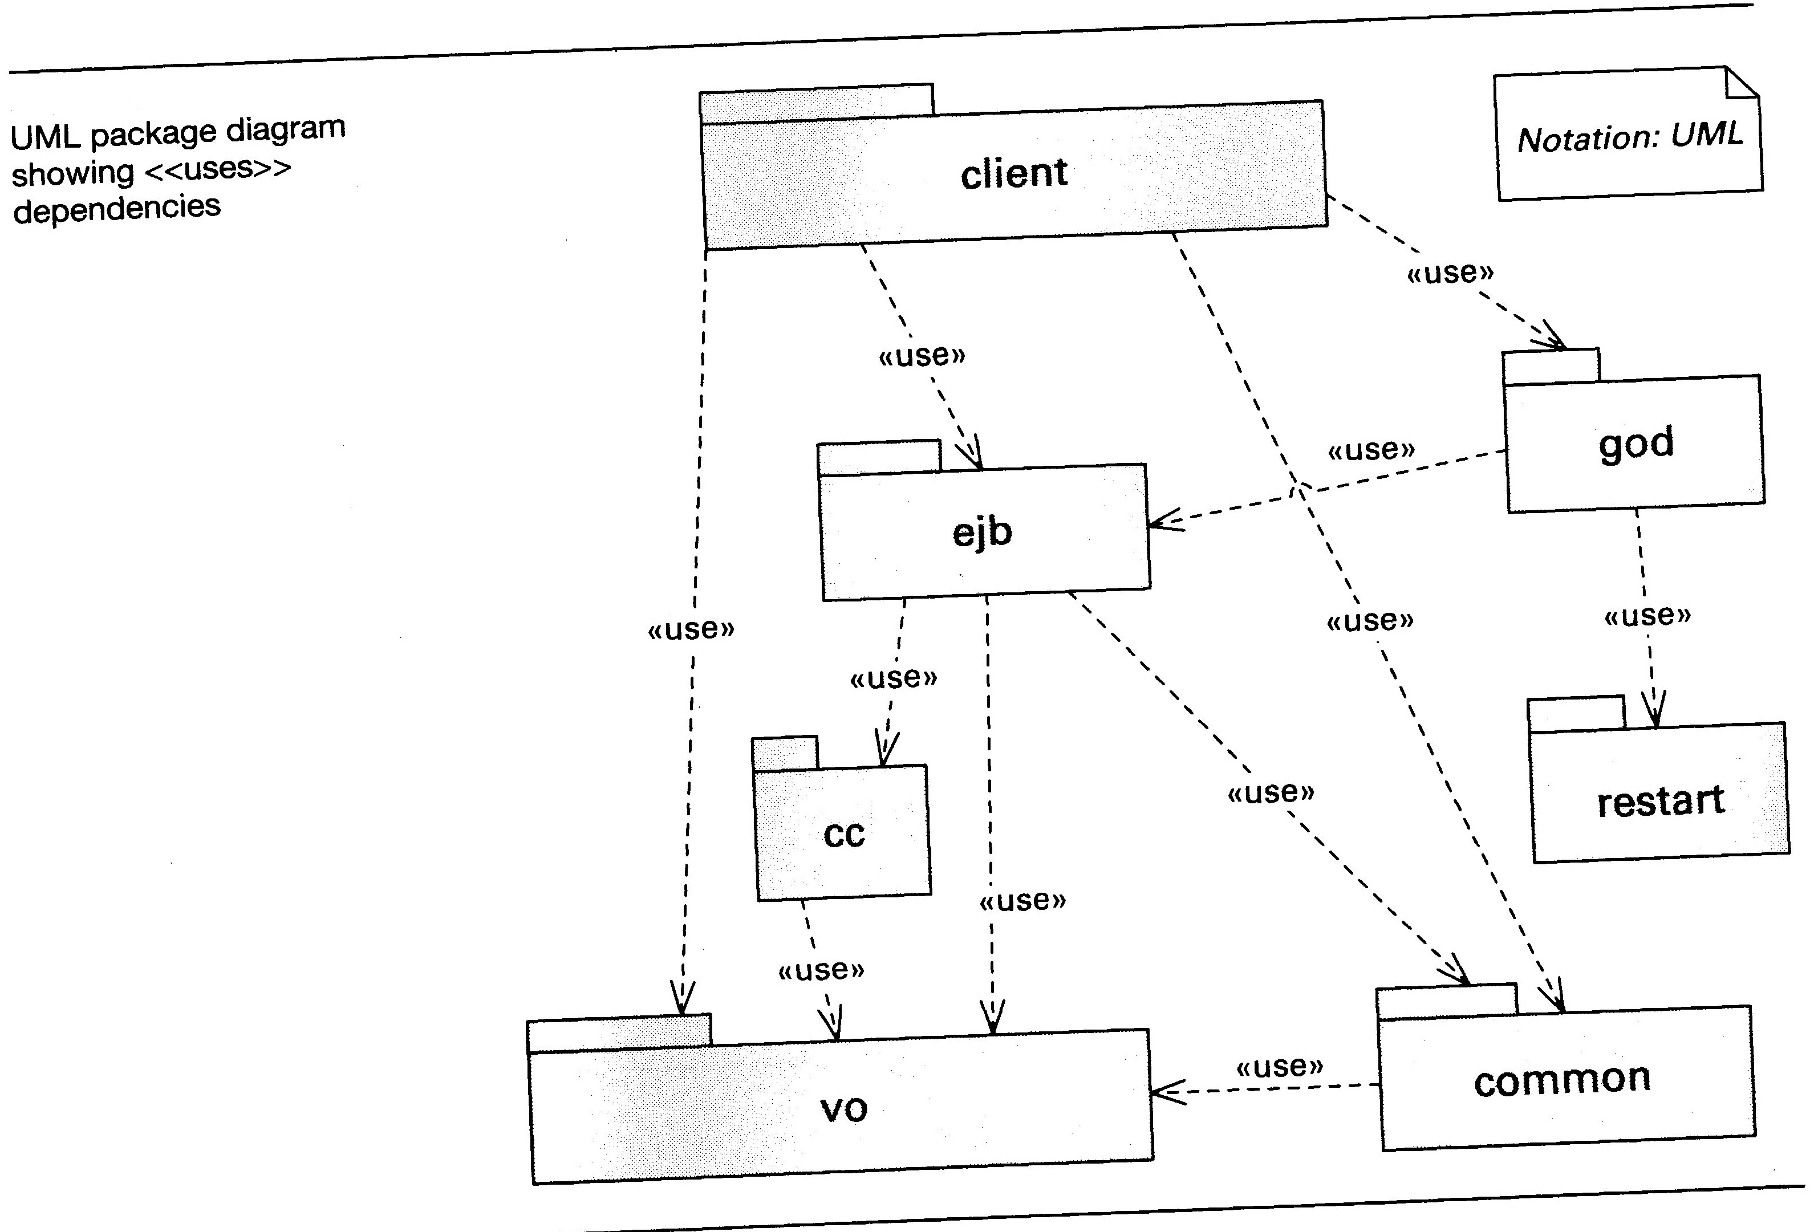
Figure 4: Example Uses diagram from Clements et al. (2011), Figure 2.8.
<Enter text here that describes each of the elements of the above diagram, similar to the example in Section 4.2 >
[OPTIONAL] Uses dependencies may also be represented in a Dependency Structure Matrix (DSM) as shown below.
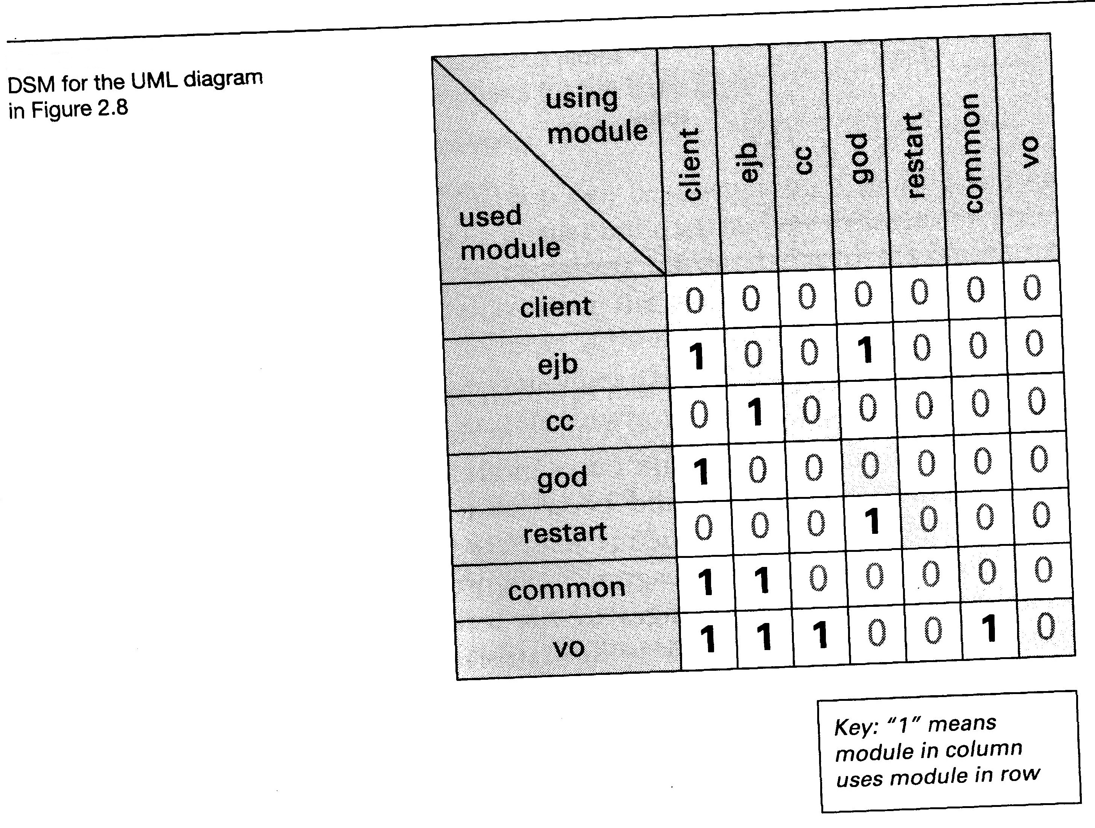
Figure 5: Example of a Dependency Structure Matrix from Clements et al. (2011), Figure 2.9.
<Enter text here that describes each of the elements of the above diagram, similar to the example in Section 4.2 >
  - Layered View
[OPTIONAL] The Layered view depicts the allowed-to-use relationship between groups of modules called layers. Some CDR code may have this structure, although it is more likely to be seen in an application with a graphical user interface and an underlying database, or in an operating system.
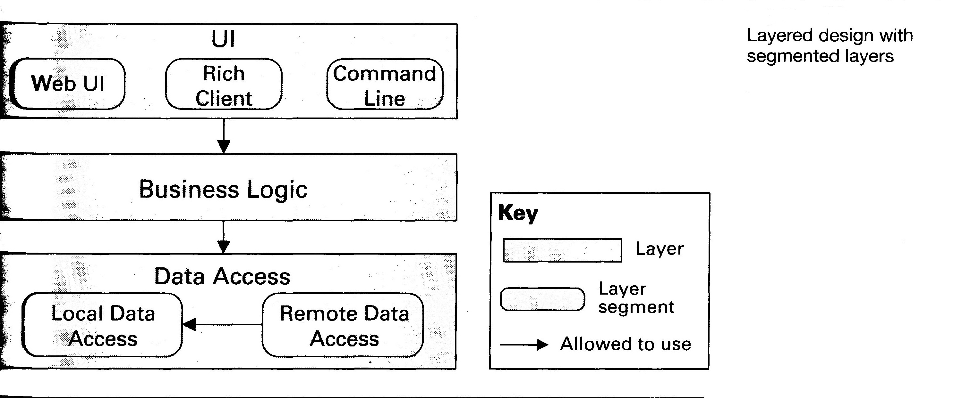
Figure 6: Example layered view from Clements et al. (2011), Figure 2.20.
<Enter text here that describes each of the elements of the above diagram, similar to the example in Section 4.2 >
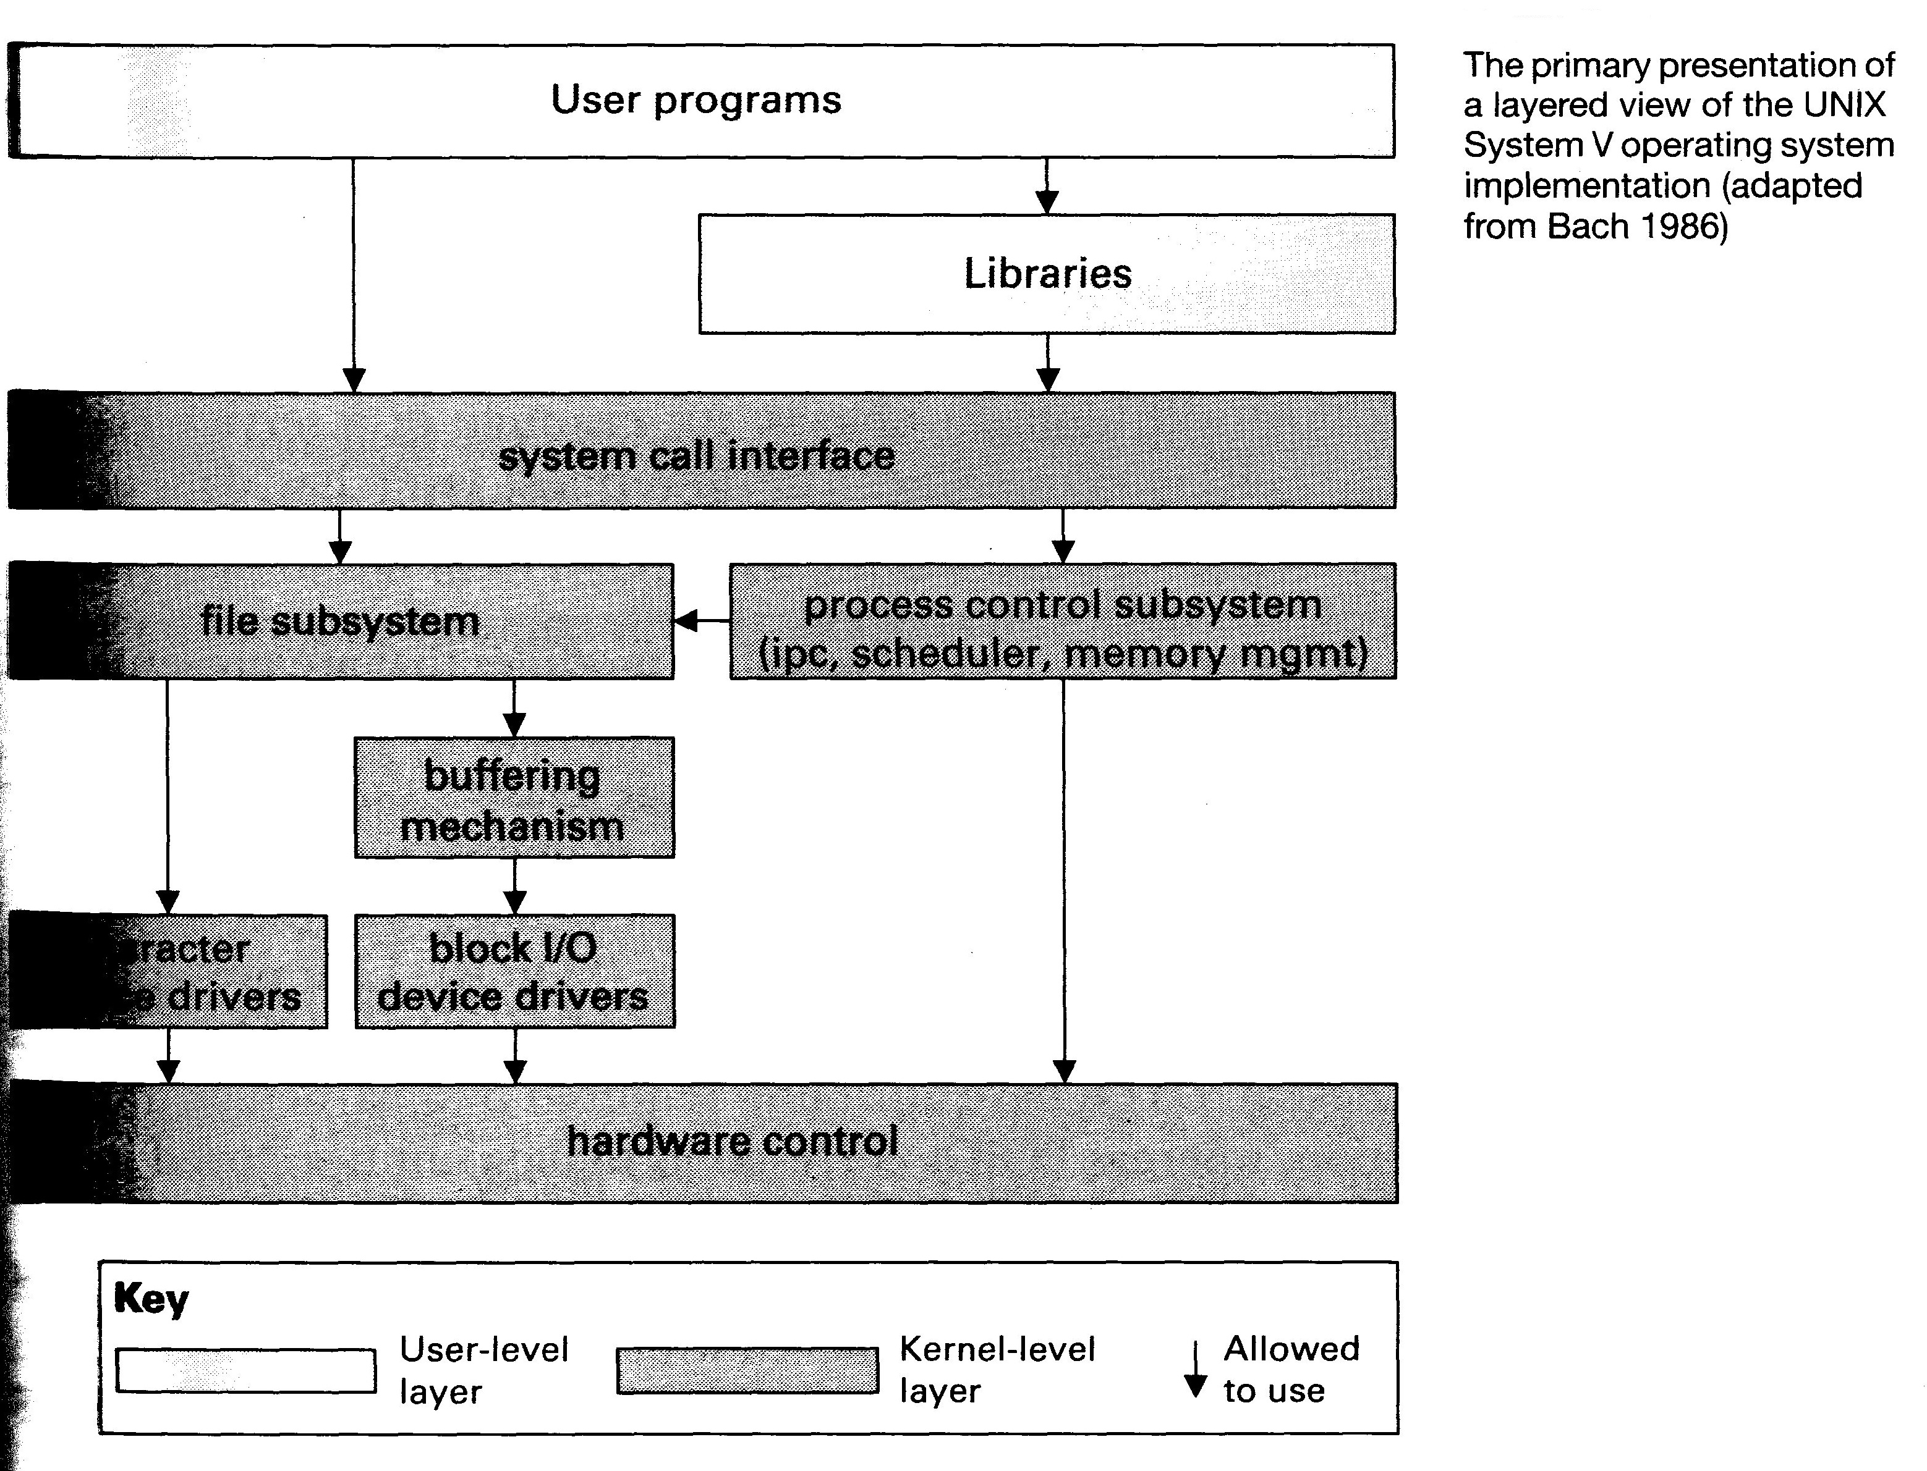
Figure 7: Example Layered view from Clements et al. (2011), Figure 2.26.
<Enter text here that describes each of the elements of the above diagram, similar to the example in Section 4.2 >
  - Generalization
[OPTIONAL] A generalization diagram is useful for showing “is-a” relationships among modules, in order to support extension and evolution of architectures and individual elements. In the CDR domain it may be particularly useful for representing specializations of interfaces, e.g., for supporting the substitution of one data input with another input having a different format.
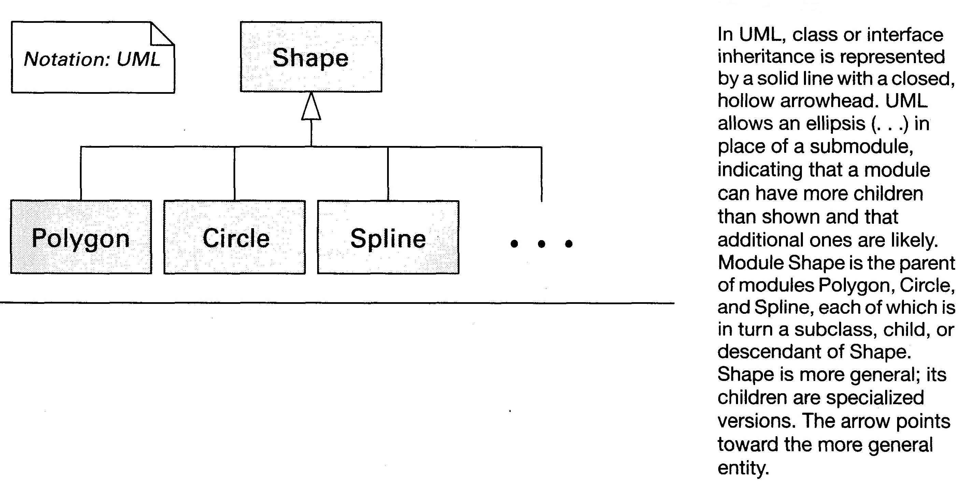
Figure 8: Example Generalization diagram from Clements et al. (2011), Figure 2.12.
<Enter text here that describes each of the elements of the above diagram, similar to the example in Section 4.2 >
  - Aspects
This section discusses crosscutting concerns that affect the entire software product.
    - Quality Flags
[REQUIRED] Identify all of the quality flags that appear in output files, the values they may take, the conditions that lead to those values, and the modules and routine where they are set.
<Enter Text or Table Here>
    - Numerical Computation
[REQUIRED] Discuss any possible issues with computationally intensive operations (e.g., large matrix inversions), and any situations that could lead to inaccurate results, exceptions, or infinite loops (e.g., the effects of round-off error on operations involving both very large and very small numbers).
<Enter Text Here>
    - Performance Optimization
[REQUIRED] Describe any performance issues, and whether or not there are any actual or potential performance optimizations within the code.
<Enter Text Here>
    - Parallelization
      - Trivial Parallelization
[REQUIRED] This section should describe any parallelization that can be performed by running separate instances of the executable components, such as running each orbit separately, on different machines, and not necessarily in time order. A diagram may be helpful. If the algorithm design prevents such parallelization then that should be described. For example, if each day needs to be initialized by the preceding day, discuss the reason for that, and explain how the first day should be initialized for a reprocessing run.
<Enter Text Here>
      - Parallelization Implemented Within the Code
[REQUIRED] This section should describe any parallelization implemented within the code, e.g., by using the Message Passing Interface (MPI). If no such parallelization exists, enter “Not Applicable”. A diagram will probably be helpful.
<Enter Text Here>
    - Exception Handling
[REQUIRED] List the complete set of expected and possible exceptions, and describe how they are identified, trapped, and handled throughout the software.
<Enter Text Here>
- Process View
The process view focuses on run-time behavior.
  - Invocation
Provide a brief description of how the various executable components and scripts are run to produce the output data products and perform any associated activities. Specific instructions on CDR Data Processing are discussed later.
<Enter text here >
    - Command Line(s)
Present a synopsis of the command line(s), similar to the synopsis section of Unix-style man pages. If the software provides online help there is no need to duplicate that here, only the option(s) needed to display this help. If there is more than one executable component or script use a separate subheading for each (CDRHeading 4 style)
<Enter text here >
    - Control Files
[REQUIRED] For each control file input, create a new sub-heading and table following the examples given here as appropriate.
      - Control File for clavrxorb
<Enter text here if needed>
Table 2: Control file for clavrxorb
Attribute | Value
File Name | clavrxorb_default_options (default; command line option can override)
Used By Component | clavrxorb
Purpose | Sets defaults for command line options, as well as other run-time settings.
Creation Method | Manual edit
Format & Version | ASCII fixed positioning; no versioning
Commenting Method | Characters following ‘!’ are ignored to the end of line, but entire lines cannot be commented out
Read By Routine | avhrr_calnav_routines:read_clavrxorb_default_options()

[REQUIRED] Provide a control file sample following the example given here.
Example control file for clavrxorb
1 !ref_cal_1b flag (0 = do not use reflectance cal in level 1b)
0 !therm_cal_1b flag (0 = do not use thermal cal in level 1b)
0 !1bx flag (1 = fill in clavr-x bytes in level 1b)
0 !nav flag (0=level-1b,1 = clevernav)
0 !write nav out (1 = write to a nav file)
0 !cmr file flag (0=no,1=make output file)
0 !obs file flag (0=no,1=make output file)
0 !geo file flag (0=no,1=make output file)
0 !cld file flag (0=no,1=make output file)
0 !sst file flag (0=no,1=make output file)
0 !rtm file flag (0=no,1=make output file)
0 !ash file flag (0=no,1=make output file)
1 !level2 file flag (0=no,1=make output file)
0 !level3 file flag (1 = make gridded output)
0 !cloud mask 1b (1 = read from 1b and don't recompute)
1 !bayesian cloud mask (0=no, 1 = yes)
1 !sst flag (0= no, 1 = yes)
1 !cld flag (0= no, 1 = yes)
1 !aot flag (0= no, 1 = yes)
1 !erb flag (0= no, 1 = yes)
0 !ash flag (0= no, 1 = yes)
1 !use oisst
0 !oisst option (0 = determine file, 1 = use oisst.current)
0.5 !grid resolution
0 !grid format: eq. area (0) / eq. angle (1)
1 !output compression flag (0=no,1=gzip,2=szip)
0 !subset pixel hdf flag (0=no / 1= yes)
1 !nwp flag (1=gfs,2=ncep reanalysis,3=cfsr)
1 !rtm flag (0=crtm,1=pfast)
1 !use modis clear ref (0=no,1=yes)
1 !prob_clear_res_flag (0=no,1=yes)
1 !lrc_flag (0=no,1=yes)
0 !process undetected cloud (0=no,1=yes)
0 !diagnostic output flag
0 !node for diagnostic output (0=asc,1=des)
20.0 !minimum latitude for diagnostic output
40.0 !maximum latitude for diagnostic output
/data1/Ancil_Data/clavrx_ancil_data/
/data1/Ancil_Data/gfs/hdf/
/data1/Ancil_Data/ncep-reanalysis/
/data1/Ancil_Data/cfsr/hdf/
/data1/Ancil_Data/oisst_daily/
/data1/Ancil_Data/snow/
/data1/Ancil_Data/GlobSnow/
/data1/Ancil_Data/Dark_Composites/
./temporary_files/
1 !smooth nwp flag (0=no, 1 = yes)
1 !seebor emiss flag (0=no, 1 = yes)
1 !read hires sfc type flag (0=no-8km, 1 = yes-1km)
1 !read land mask flag (0=no, 1 = yes)
1 !read coast mask flag (0=no, 1 = yes)
1 !read surface elevation flag (0=no, 1 = yes)
0 !read volcano mask flag (0=no, 1 = yes)
0.0 180.0 !solar zenith angle limits
1 !read snow mask flag (0=no, 1 = IMS, 2 = GlobSnow)
0 !read dark composite flag (0=no, 1 = yes)
0 0 0 0 0 0 !chan on flags of channels 7,8,9,10,11,12
0 0 0 0 0 0 !chan on flags of channels 13,14,15,16,17,18
0 1 0 0 0 0 !chan on flags of channels 19,20,21,22,23,24
0 0 0 0 0 0 !chan on flags of channels 25,26,27,28,29,30
1 1 0 0 0 0 !chan on flags of channels 31,32,33,34,35,36
1 1 0 0 0 1 !chan on flags of channels 1,2,3,4,5,6
3 ! DCOMP MODIS MODE (1 = 0.6/1.6 . 2 = 0.6/2.2 3 = 0.6/3.7 )
1 ! ACHA MODE (0=11;1=11/12;2=11/13.3;3=11,12,13;4=8.5/11/12;5=6.7,11,12;6=6.7,11,13.3)
modis_6term_cfsr_globsnow_bayes_mask.txt
  - Input Data
    - Remote Sensed Inputs
For each remotely sensed measurement input, create a new sub-heading (CDRHeading 4) and table, following the AVHRR example given here.
<Enter text here if needed>
      - Remote Sensed Infrared Radiance
<Enter text here if needed>
Table 3: Remote Sensed Infrared Radiance Input
Attribute | Value
File Type | AVHRR Level 1b Global Area Coverage
Naming Convention | See NOAA KLM Guide, Section 8.2
Format & Version | See NOAA KLM Guide, Section 8.3.1.4
Byte Order | Indicate big-endian or little-endian if relevant
File Coverage | 1 orbit
Size | 3.7 MB compressed (typical)
Special Error Values | TBD
Location of Authoritative Copy | Order from CLASS (http://www.class.ncdc.noaa.gov/saa/products/welcome) and when the files are ready, they will provide a download link.

    - In-situ Measurement Inputs
For each in-situ measurement input, create a new sub-heading (CDRHeading 4) and table, following the example given here.
<Enter text here if needed>
      - Ship and Buoy Sea Surface Temperatures
<Enter text here if needed>
Table 4: Near Real Time Ship and Buoy Sea Surface Temperatures
Attribute | Value
File Type | ASCII, gzipped
Naming Convention | gts1day.dat.gz
Format & Version
Byte Order | Indicate big-endian or little-endian if relevant
File Coverage | Last 24 hours. Updated as new data appear
Size
Special Error Values | TBD
Location of Authoritative Copy | ftp://ftp.emc.ncep.noaa.gov/cmb/misc/rwr/gts1day.dat.gz

    - Ancillary Inputs
[REQUIRED] For each ancillary input, create a new sub-heading and table following the AVHRR example given here. Lookup tables are considered to be ancillary data and should be included here. A later section discusses the generation of lookup tables.
<Enter text here if needed>
      - AVHRR Instrument and Algorithm Constants
Note: This is not the complete set of ancillary data for AVHRR analyses. See Table 2 in CDRP-PILOT-0095 for more info.
<Enter text here if needed>
Table 5: AVHRR Instrument and Algorithm Constant Files
Attribute | Value
Description | Narrative describing the contents of the file
File Type | Tar file
Naming Convention | avhrr_const_files.tar
Format & Version | No documentation available
Byte Order | Indicate big-endian or little-endian if relevant
File Coverage | Period of record
Typical Size | 53 kB
Date | 10/18/2010
Location of Authoritative Copy | ftp://ftp.ssec.wisc.edu/clavr/ancil_data/

    - Lookup Table Generation
[REQUIRED] Lookup tables are used to parameterize the results of computationally intensive calculations that would otherwise have to be performed many times during a data analysis run, e.g., radiative transfer models. For each lookup table, create a new sub-heading following the Radiative Transfer outline given here.
      - Radiative Transfer Lookup Table
Identify the table and describe how it is generated, including references to the software package, and the providing organization.
<Enter text here>
  - Input Validation
[REQUIRED] Discuss how the various inputs are validated, with reference to the specific modules defined in Section 4.
<Enter Text Here>
  - Intermediate Outputs
[REQUIRED] Identify any intermediate output files, i.e. files written by one component and subsequently read by another component. Add one subheading and table for each, following the clavrx example given. It is assumed that most of these files can be discarded at the end of the processing run (orbit, day, etc.). Exceptions are noted in the “Persistence” row of the table below.
    - Level 2 HDF Intermediate Output
<Enter text here if needed>
Table 6: Level 2 HDF Intermediate Output from clavrxorb
Attribute | Value
File Type | Level 2 pixel file
Relative Path | <out>/Lev2/<Level 1b base name>.level2.hdf
Format & Version | HDF Version 4.2
Byte Order | Indicate big-endian or little-endian if relevant
Frequency | 1 per orbit
Typical Size | 41 MB uncompressed
Special Error Values | TBD
Persistence | Identify whether the file needs to be retained, e.g., to initialize the next orbit/day, and if so, how long it should be retained in the staging area. Intermediate outputs that need to retained permanently are further identified in the “Collateral Outputs” section

  - Final Outputs
    - Output Files Containing CDR Variables
[REQUIRED] Create a new sub-heading and table for each output file that contains CDR variables, following the clavrx example given here.
      - Global Grid File
<Enter text here if needed>
Table 7: Global Grid Output File
Attribute | Value
File Type | Level 2b global grid
Relative Path | <out>/Lev2b/patmosx_<scid>_<node>_<year>_<doy>.level2b.nc
Format & Version | NetCDF Version 4.2
Byte Order | Indicate big-endian or little-endian if relevant
Frequency | 1 per day
Typical Size | 14 MB uncompressed
Special Error Values | TBD

    - Collateral Output Files
[REQUIRED] If there are any additional output files that need to be retained, identify each of them in a subsection following the pattern above. Use N/A if there are no such files. Log files are discussed separately in the next section.
<Enter text here if needed>
Table 8: <TBD> Collateral Output File
Attribute | Value
File Type
Relative Path
Format & Version
Byte Order | Indicate big-endian or little-endian if relevant
Frequency
Typical Size
Special Error Values | TBD
Known Uses

    - Output Files for Operational Monitoring
[REQUIRED] Identify all of the log files and any other files that are (or could be) used for operational monitoring and troubleshooting, following this clavrx example. All such files should be identified, even if they are not being used.
Table 9: Output Files for Operational Monitoring
Stream or File Name | Format | Output By | Used For
<stdout> | ASCII | clavrxorb | Troubleshooting, performance analysis
<stderr> | ASCII | clavrxorb | Troubleshooting, performance analysis
<stdout> | ASCII | comp_asc_des_level2b | Troubleshooting, performance analysis
<stderr> | ASCII | comp_asc_des_level2b | Troubleshooting, performance analysis
SASRAB_LogFile | unknown | clavrxorb | Troubleshooting, performance analysis

[REQUIRED] Provide a narrative discussion of the above table, including: (1) the recommended names and locations of the files to which the stdout and stderr streams are written (noting that these streams should not be merged, as required by CDRP-STD-0007:110); (2) the locations of the named files and whether or not this location is configurable, with reference to the relevant control files in Section 5.1.2; (3) The nature of the informational and error messages, how they can be distinguished from each other, and whether such information can be quickly parsed, e.g., by ‘grep’; and (4) other information useful for operational monitoring (possibly extensive)
<Enter text here>
  - CDR Data Processing
This section provides specific instructions on to create the Climate Data Record data product(s).
    - CDR Reprocessing
[REQUIRED] Provide a step-by-step procedure for reprocessing the period of record. These instructions should reference the information given above.
<Enter text here>
    - CDR Forward Processing
[REQUIRED] Provide a step-by-step procedure for performing forward processing. These instructions should reference the information given above.
<Enter text here>
    - Processing For Preliminary Data Products
[OPTIONAL] Provide a step-by-step procedure for producing the preliminary data products described in Section 3.3. These instructions should reference the information given above. The section heading may be changed to match the product name, but should be consistent with the heading used for Section 3.3.
<Enter text here>
- Development View
This section provides essential information for the maintenance programmer.
  - Code Layout
[REQUIRED] This section should show an annotated layout of the code tree as checked out from version control. It is not necessary to show every file. However, all of the Makefiles and any build scripts should be shown explicitly, as well as each source file that contains an entry point (“main”) for a compiled component. The example here is for clavrx.
<Enter Text Here>

./clavrx
clavrxorb_default_options ! Control file template for clavrxorb
clavrxorb_file_list ! Input file list template for clavrxorb
grib2hdf/ ! Utility for GRIB to HDF conversion
src/ ! Main source directory
Makefile ! Builds clavrxorb and
comp_asc_des_level2b.f90 ! Main line for comp_asc_desc_level2b
process_clavrx.f90 ! Main line for clavrxorb
...

  - Data Model
[OPTIONAL] The data model view shows relationships among data entities. At increasing levels of detail, this view may be conceptual, logical, or physical. Typically data models are used to represent relational databases. However, a data model may useful for representing input and output data structures. For example, the input data may be in the form of pixels contained in scan lines, which in turn are contained in a file for one orbit. The first example below uses Crows Foot notation (see http://en.wikipedia.org/wiki/Entity–relationship_model and references therein).
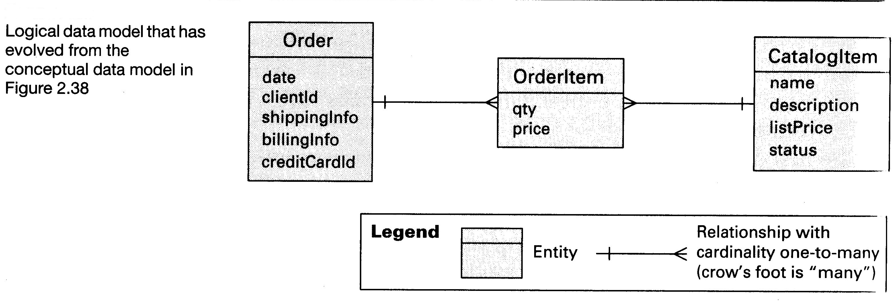
Figure 9: Example Logical Data Model from Clements et al. (2011), Figure 2.39
<Enter text here that describes each of the elements of the above diagram, similar to the example in Section 4.2 >
[OPTIONAL] For data structures in memory it may be better to use a UML class diagram as shown below.
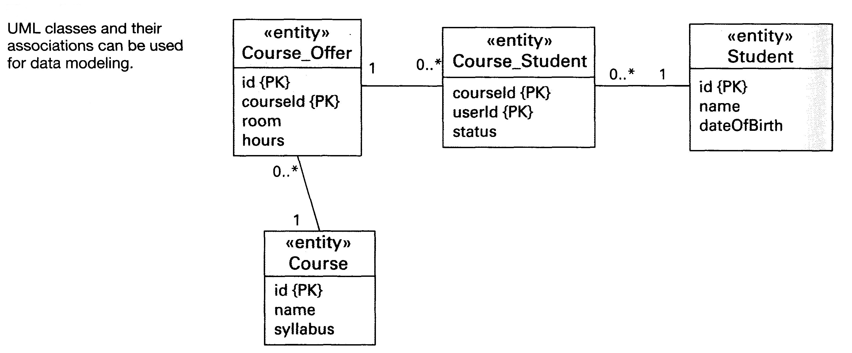
Figure 10: Example Logical Data Model depicting internal data structures using a UML class diagram, from Clements et al. (2011), Figure A.7.
  - Build Instructions
[REQUIRED] This section should explicitly state how to create the executable components from the source code, and how to create the delivery package. Include any other considerations. This section is the “master” whose contents should be mirrored in the README file at the top level of the source tree.
<Enter Text Here>

- Physical View
The physical view describes the mapping(s) of the software onto the hardware and reflects the distributed aspects of both hardware and software.
  - CPU Resource Needs and Limitations
[REQUIRED]
Computing resource needs for this algorithm are defined in Table 10 below.
Table 10: Computing Resource Needs
Computing Resource | Need
Operating System | Centos 6.2
Number of CPU cores | 1 core
CPU Type | Intel x86
Byte Order | Indicate limitation to big-endian or little-endian if relevant
Memory Width | 32 or 64 bit
Data Bus Width | 32 or 64 bit
Memory per CPU | Such as 4 GB
CPU time per month of record processed | XX.Y Hours (2 or 3 significant figures)
Elapsed time per month of record processed | XX.Y Hours (2 or 3 significant figures)

<Enter additional text here discussing the above table>
  - Operating System
[REQUIRED] Identify the target operating system (including version number) for which this software was developed. Also identify any known portability issues to other operating systems.
<Enter Text Here>
  - Deployment
[REQUIRED] A Deployment View shows how the elements from the Component and Connector views are allocated to the hardware of the operational environment (which may be virtual). Such diagrams are often used to represent the entire software architecture, but that cannot be done effectively with a single view.
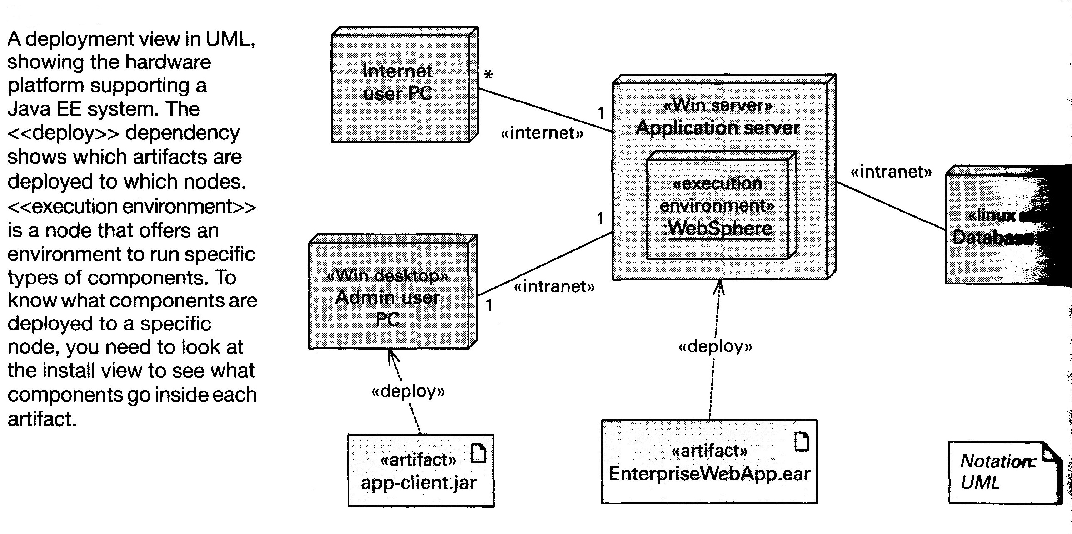
Figure 11: Example deployment view from Clements et al. (2011), Figure 5.3.
<Enter text here that describes each of the elements of the above diagram, similar to the example in Section 4.2>
  - Data Staging Area
    - Staging Area Storage Needs
[REQUIRED] Summarize the total storage required for processing or reprocessing, per month of record. Three significant figures are sufficient. This table is a summary of the information in Section 5. Follow with a narrative discussing approaches to managing this storage, particularly with regard to the intermediate storage, and referencing the file persistence identified in Section 5.4. Collateral outputs should be included under “Output”.
Table 11: Data Storage Needed per Month of Record (Gigabytes)
Input | Ancillary | Peak Intermediate | Output

<Enter text here>
    - Staging Area Layout
[REQUIRED] Describe the file system layout of the staging area(s) for input, intermediate, and output data, as well as the directory for log files and any other files automatically created for problem diagnosis. This section should also reference any configuration files in Section 5 that define this layout. This section should also discuss in detail whether part or all of the staging area needs direct-attached storage in order to achieve satisfactory performance. A diagram may be helpful.
<Enter text and/or diagram here >
  - Install View
[REQUIRED] An Install View shows how the elements from the Component and Connector views are allocated to the file system in the operational environment.
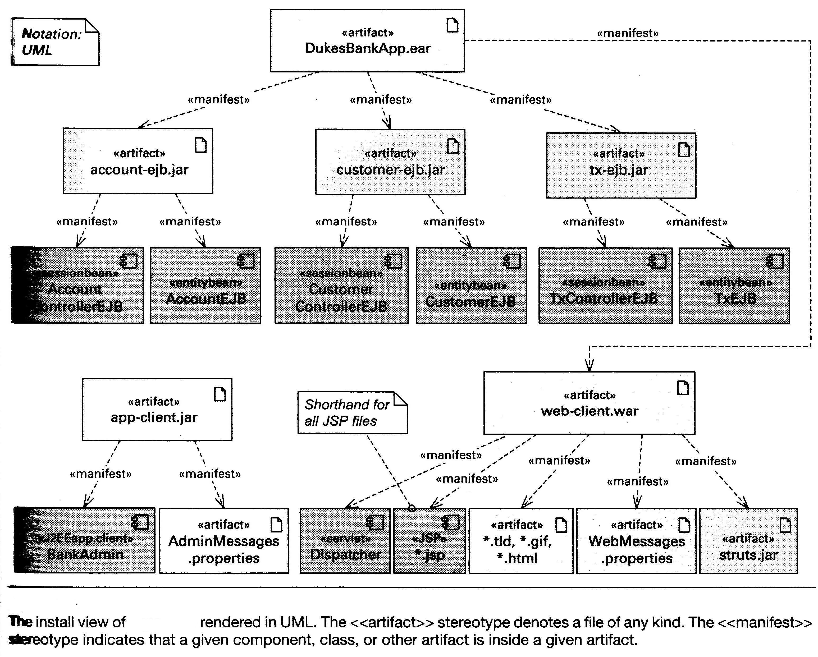
Figure 12: Example Install view from Clements et al. (2011), Figure 5.5, showing unpacking of the installation packages DukesBankApp.ear and app-client.jar into individual components installed on the production file system. Most CDRs will be simpler than this.
<Enter text here that describes each of the elements of the above diagram, similar to the example in Section 4.2 >
  - Installation Procedure
[REQUIRED] Identify the steps needed to install and configure in the operational environment, as well as the steps needed to verify that the software has been correctly installed and configured.
<Enter text here >

- Test Datasets and Tools
  - Test Input Datasets
[REQUIRED] Describe the test input datasets used to characterize the performance of the algorithm and quality of the data product(s), including the breadth of the domain (typical versus stressing states) used in the analysis and assessment. For the CDR Program it is expected that test inputs primarily consist of operational data rather than simulated data. Please also identify any known gaps in test coverage by these datasets. This section should elaborate on the corresponding section in the C-ATBD.
<Enter Text Here>
  - Expected Output Datasets
[REQUIRED] Describe the datasets containing expected results (“golden” data sets), against which the algorithm output can be compared.
<Enter Text Here>
  - Test Output Analysis
[REQUIRED] Describe the steps needed to verify that test results obtained using the above data sets are in sufficient agreement to accept a change in the code. This section should identify the specific tools to be used for comparison and also specify the maximum allowable numerical difference for each variable.
<Enter Text Here>

- Data Dictionary
This section identifies all of the various input and output variables.
  - Input Variables
    - Sensor or Measurement Inputs
[REQUIRED] Either:
                - Fill out the following table for each variable contained in sensor (measurement) input files, following the example given. Sensors may be remote or in situ; or
                - Provide complete references as to where this information may be easily obtained (which could mean referencing comments in the code at the point where the variables are declared and/or read in).
The input files may have additional metadata but there is no need to repeat that here.
Table 12: Measurement Input Data Dictionary
Variable name in code | Physical Dimension | Type and Size | Appears in File(s)
latitude | Geocentric Latitude in Degrees North | Real *4 | AVHRR Level 1b GAC

    - Ancillary Inputs
[REQUIRED] Either:
                - Fill out the following table for each ancillary input variable following the example given; or
                - Provide complete information and references as to where this information may be easily obtained (potentially including comments in the code at the point where the variables are declared and/or read in).
The input files may have additional metadata but there is no need to repeat that here.
Table 13: Ancillary Input Data Dictionary
Variable name in code | Physical Dimension | Type and Size | Appears in File(s)
sst | Sea Surface Temperature in Degrees Celsius | Real *4 | OISST AVHRR-Only

  - Intermediate Output Variables
[REQUIRED if the processing involves two or more executable components]
Either:
                - Fill out the following table for each variable contained in intermediate output files, following the example given; or
                - Provide complete references as to where this information may be easily obtained (which could mean directing the reader to comments in the code at the point where the variables are declared and/or have their values defined).
Intermediate output files may have additional metadata but there is no need to repeat that here.
Table 14: Intermediate Output Variables
Output By Component | Name in Code | Physical Dimension | Variable Set in Routine(s) | Output File(s)
clavrxorb | lat | Latitude in Degrees North | process_clavrx() | Level_2
clavrxorb | lon | Latitude in Degrees East | process_clavrx() | Level_2

  - Final Output Variables
    - Geolocation, Orientation, and Time Output Variables
[REQUIRED] Identify each of the output variables related to the measurement geolocation, orientation and time, its physical dimensions, and the output file(s) in which it appears, according to the clavrx example given here. The metadata name is from the NetCDF header. The variable name in the code should be the name at the point where the variable is filled. Additional attributes of these variables should be present in the file-level metadata and need not be repeated here.
Table 15: Geolocation, Orientation, and Time Output Variables
Name in Code | Metadata Standard Name | Physical Dimension | Variable Set in Routine(s) | Output File(s)
lat | Latitude | Latitude in Degrees North | process_clavrx() | Level_2b
lon | longitude | Latitude in Degrees East | process_clavrx() | Level_2b

    - CDR Output Variables
[REQUIRED] Identify each of the CDR output variables, its physical dimensions, and the output file(s) in which it appears, according to the clavrx example given here. The metadata name is from the NetCDF header. The variable name in the code should be the name at the point where the variable is filled. Additional attributes of these variables should be present in the file-level metadata and need not be repeated here.
Table 16: CDR output variables appearing in the Level_2b output file
Name in Code | Metadata Standard Name | Physical Dimension | Structure | Variable Set in Routine(s)
Ref_Ch1 | ch1_reflectance | Dimensionless | value[[lat][lon]] | avhrr_calnav_routines:ref_cal_coeffs()
Ref_Ch2 | ch2_reflectance | Dimensionless | value[[lat][lon]] | avhrr_calnav_routines:ref_cal_coeffs()
Ref_Ch6 | ch3a_reflectance | Dimensionless | value[[lat][lon]] | avhrr_calnav_routines:ref_cal_coeffs()

    - Collateral Output Variables
[REQUIRED] Identify each of the collateral output variables, its physical dimensions, and the output file(s) in which it appears, according to the clavrx example given here. The metadata name is from the NetCDF header. The variable name in the code should be the name at the point where the variable is filled. Additional attributes of these variables should be present in the file-level metadata and need not be repeated here.
Table 17: Collateral output variables appearing in the Level_2b output file
Name in Code | Metadata Standard Name | Physical Dimension | Structure | Variable Set in Routine(s)
cloud_type | cloud_type | Enumerated Dimensionless | value[[lat][lon]] | avhrr_calnav_routines:ref_cal_coeffs()

- Acronyms and Abbreviations
Acronym or Abbreviation | Definition
C-ATBD | Climate Algorithm Theoretical Basis Document
CDR | Climate Data Record
CDRP | Climate Data Record Program
CM | Configuration Management
CPU | Central Processing Unit
FOC | Full Operational Capability
ICDR | Interim Climate Data Record
IOC | Initial Operating Capability
MD5 | Message Digest 5
MPI | Message Passing Interface
NCDC | National Climatic Data Center
NESDIS | National Environmental Satellite, Data, and Information Service
NOAA | National Oceanic and Atmospheric Administration
OAD | Operational Algorithm Description
SOP | Standard Operating Procedure
UML | Unified Modeling Language

- Glossary
[REQUIRED] Edit this table to define all technical terms used in this document. Technical terms used in the code but not in this document should not appear here. Technical terms include scientific and engineering terms that either do not appear in an ordinary dictionary, or which have specific meanings in the respective domain.
Term | Definition
Software Architecture | The software architecture of a program or computing system is the structure or structures of the system, which comprise software components, the properties of those components, and the relationships between them. The term also refers to documentation of a system's software architecture. Documenting software architecture facilitates communication between stakeholders, documents early decisions about high-level design, and allows reuse of design components and patterns between projects. [NASA NPR-7150.2A]

- Optional
Add appendices as needed, using the CDRAppendixHeading style to make these headings show up in the Table of Contents.
<Add text here>

